**KALLAM HARANADHAREDDY INSTITUTE OF TECHNOLOGY**

**(AUTONOMOUS)**

### Project Title

CRM Application for Jewel Management - (Developer)

### By

##### BADIPATLA VENKATA NAGA SIMHA VINAY [218x1a4205@khitguntur.ac.in](mailto:218x1a4b3@khitguntur.ac.in)

**CHIGURUPATI DHANUSH KRISHNA VENKAT**

**[218x1a4214@khitguntur.ac.in](mailto:218x1a4267@khitguntur.ac.in)**

##### PERALI CHANDRA SEKHAR

**[218x1a4242@khitguntur.ac.in](mailto:218x1a4272@khitguntur.ac.in)**

##### MEDISETTY KARTHIK

**[218x1a4234@khitguntur.ac.in](mailto:218x1a4287@khitguntur.ac.in)**

**PROJECT OVERVIEW**

The Jewel Inventory System is a sophisticated software solution meticulously crafted to revolutionize and optimize the inventory and sales operations of jewellery stores and manufacturers.

This all-encompassing system is engineered to deliver an efficient, user-centric experience that ensures precision and control in managing an extensive range of jewellery items.

The Jewel Inventory System enables businesses to streamline inventory management by easily tracking and monitoring stock levels, categorizing items, and managing inventory across multiple locations with unparalleled accuracy.

Additionally, it simplifies sales transactions through an intuitive interface that supports quick invoicing, real-time updates, and seamless integration with various payment gateways.

With its commitment to accuracy, the system maintains comprehensive and detailed records of inventory movements, sales history, and customer data to ensure transparency and informed decision-making.

Designed with the end-user in mind, the system offers a straightforward, easy-to-navigate interface that enhances productivity and reduces the learning curve.

By leveraging cutting-edge technology and innovative features, the Jewel Inventory System empowers businesses to maintain operational excellence, optimize resources, and drive growth.

1. Real Time Salesforce Project.
2. Data Modelling.
3. Creating an application.
4. User Interface Customization.
5. Object & Relationship in Salesforce.
6. Formula fields and Validation rules.
7. Field Dependencies.
8. Record Types.
9. Cross object formula fields.
10. Conditional formatting.
11. Flows.
12. Email alerts and email templates.
13. Reports & Dashboards.

**INDEX**

|  |  |
| --- | --- |
| **S. No.** | **Topics** |
| **1.** | **Salesforce** |
| **2.** | **Object** |
| **3.** | **Tabs** |
| **4.** | **The Lightning App** |
| **5.** | **Fields** |
| **6.** | **Profiles** |
| **7.** | **Roles** |
| **8.** | **Users** |
| **9.** | **Page layouts** |
| **10.** | **Record Types** |
| **11.** | **Permission sets** |
| **12.** | **Trigger** |
| **13.** | **Permission sets** |
| **14.** | **User Adoption** |
| **15.** | **Reports** |
| **16.** | **Dashboards** |
| **17.** | **Flows** |

**INTRODUCTION**

##### Introduction to CRM Application for Jewel Management

Welcome to the future of jewellery business management with the “CRM Application for Jewel Management”, a cutting-edge solution meticulously crafted by Salesforce developers to transform the way jewellery stores and manufacturers operate. This application harnesses the power and versatility of Salesforce to deliver a seamless, efficient, and user-friendly platform designed to manage customer relationships, inventory, and sales processes with unparalleled precision.

### Key Features

1. **Customer Relationship Management:**

In the glittering world of jewellery, building strong relationships with customers is paramount. Our CRM application empowers jewellery businesses to maintain comprehensive records of customer interactions, purchase history, and preferences. This invaluable data enables businesses to offer personalized services, ensuring customer loyalty and satisfaction.

### Inventory Management:

Efficient inventory management is the cornerstone of a successful jewellery business. Our application provides real-time updates on inventory levels, allowing businesses to track and control their stock with ease. Say goodbye to stockouts and overstocking, and ensure that your inventory is always optimized.

### Sales Automation:

Streamline your sales processes with our advanced sales automation features. The application facilitates seamless transactions, automates workflows, and sends email alerts, making it easier for staff to process purchases, returns, and exchanges. Increase your sales efficiency and reduce manual efforts.

### Reporting and Analytics:

Data-driven decisions are the key to business growth. Our CRM application offers robust reporting and analytics capabilities, providing insightful reports and dashboards that visualize key business metrics such as sales performance, inventory levels, and customer behaviour. Identify opportunities for growth and make informed decisions with ease.

### User-Friendly Interface:

We understand that a user-friendly interface is crucial for effective adoption. Our application boasts an intuitive and customizable interface, allowing staff to navigate and use the system effortlessly. Tailor fields, tabs, and page layouts to meet the specific needs of your jewellery business.

By implementing the “CRM Application for Jewel Management”, jewellery businesses can unlock a new level of operational efficiency, enhance customer satisfaction, and drive sales growth. This Salesforce-based solution is tailored to address the unique challenges of the jewellery industry, providing a competitive edge and setting the stage for sustained success.

### Methodology

The development of the CRM Application for Jewel Management followed a structured and systematic approach, ensuring the delivery of a high-quality, efficient, and user-friendly solution. The following phases were critical to the successful implementation of the application:

##### Requirement Gathering and Analysis

**Stakeholder Meetings:** Engage with key stakeholders, including jewellery store owners, managers, and sales staff, to understand their needs, pain points, and expectations.

**Requirement Documentation:** Compile a comprehensive list of functional and non-functional requirements.

**Feasibility Study:** Evaluate the technical, operational, and financial aspects of the project.

##### Design and Planning

**System Architecture:** Define the overall structure, components, and their interactions.

**User Interface Design:** Create wireframes and prototypes for an intuitive and user-friendly design.

**Project Plan:** Develop a detailed project plan outlining the timeline, milestones, and resource allocation.

##### Development

**Agile Development:** Adopt an Agile approach, breaking the project into iterative cycles (sprints) for continuous improvement and timely feature delivery.

**Coding:** Implement the application using Salesforce development tools and technologies, adhering to best practices and coding standards.

**Version Control:** Utilize version control systems to manage code changes and maintain development progress history.

##### Testing

**Unit Testing:** Verify the functionality of individual components.

**Integration Testing:** Ensure seamless interaction between components and correct data flow.

**User Acceptance Testing (UAT):** Engage end-users to validate requirements and gather feedback for further improvements.

##### Deployment

**Production Environment Setup:** Configure the production environment with necessary hardware, software, and network infrastructure.

**Data Migration:** Migrate existing data from legacy systems, ensuring data integrity and accuracy.

**Deployment:** Deploy the application to the production environment.

##### Training and Support

**User Training:** Conduct training sessions to equip end-users with the knowledge and skills needed to effectively use the application.

**Documentation:** Create comprehensive user manuals and documentation.

**Ongoing Support:** Establish a support system to address post-deployment issues or questions.

##### Maintenance and Continuous Improvement

**Monitoring:** Continuously monitor application performance to identify and address issues promptly.

**Updates and Enhancements:** Release regular updates and enhancements based on user and feedback evolving business needs.

**Review and Optimization:** Periodically review application functionality and performance for optimization.

**Implementation Details**

### Implementation Details MODULE-1. SALESFORCE

#### Introduction:

Are you new to Salesforce? Not sure exactly what it is, or how to use it? Don’t know where you should start on your learning journey? If you’ve answered yes to any of these questions, then you’re in the right place. This module is for you. Welcome to Salesforce! Salesforce is game-changing technology, with a host of productivity-boosting features, that will help you sell smarter and faster.

#### What Is Salesforce?

Salesforce is your customer success platform, designed to help you sell, service, market, analyse, and connect with your customers.

Salesforce has everything you need to run your business from anywhere. Using standard products and features, you can manage relationships with prospects and customers, collaborate and engage with employees and partners, and store your data securely in the cloud.

## Creating Developer Account

Creating a developer org in salesforce.

1. Go to <https://developer.salesforce.com/signup>
2. On the sign-up form, enter the following details:
   1. First name & Last name
   2. Email
   3. Role: Developer
   4. Company: College Name
   5. Country: India
   6. Postal Code: pin code
   7. Username: should be a combination of your name and company

This need not be an actual email id; you can give anything in the format: [username@organization.com](mailto:username@organization.com)

Click on sign me up after filling these.

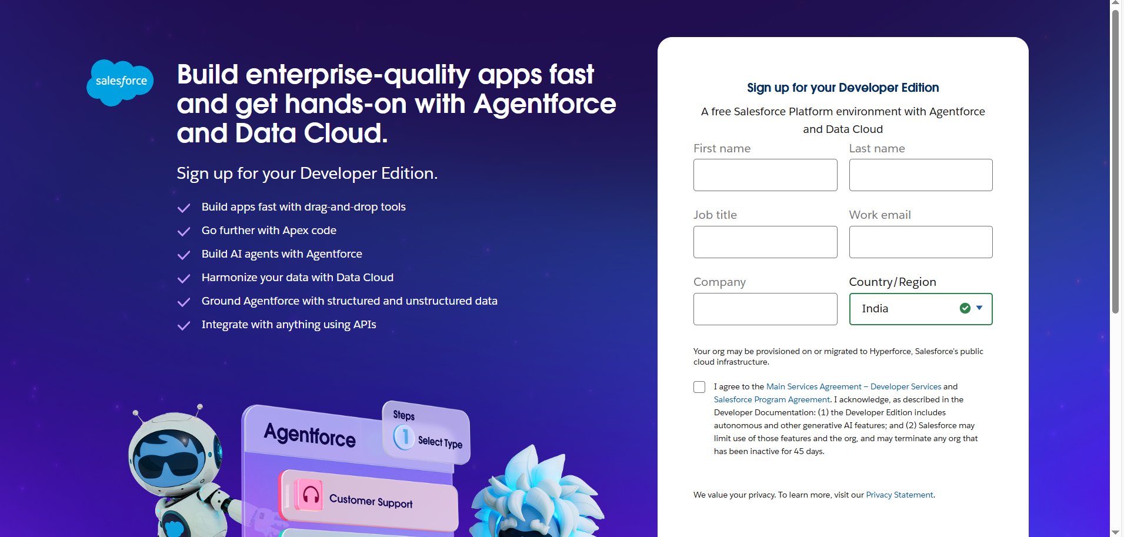

## Account Activation

1. Go to the inbox of the email that you used while signing up. Click on the verify account to activate your account. The email may take 5-10mins.

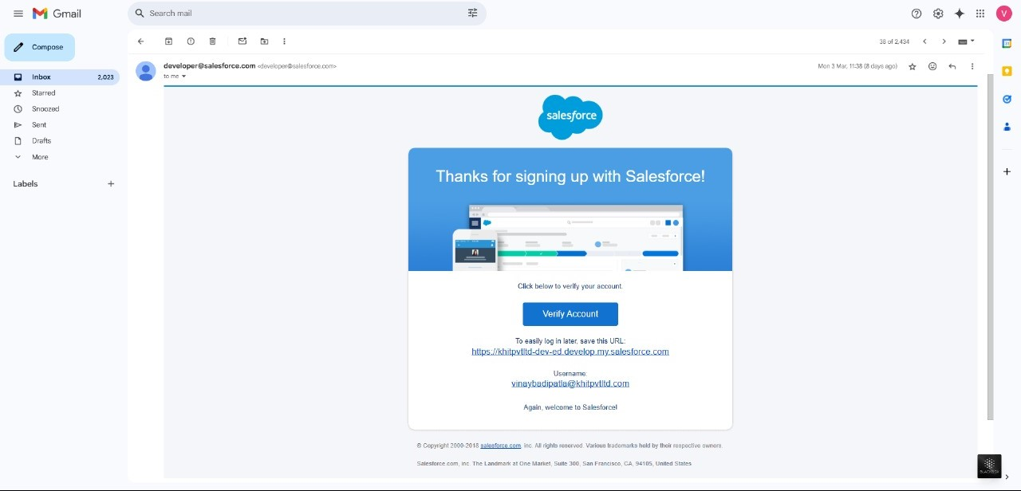

1. Click on Verify Account
2. Give a password and answer a security question and click on change password.

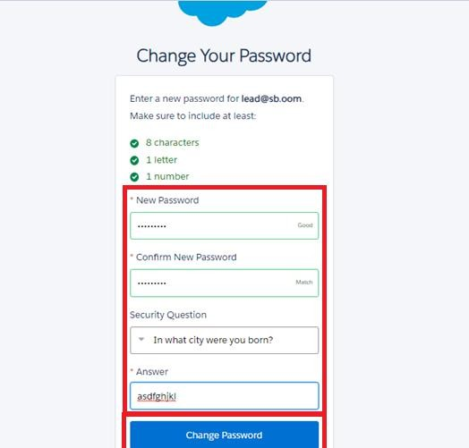

1. Then you will redirect to your salesforce setup page.

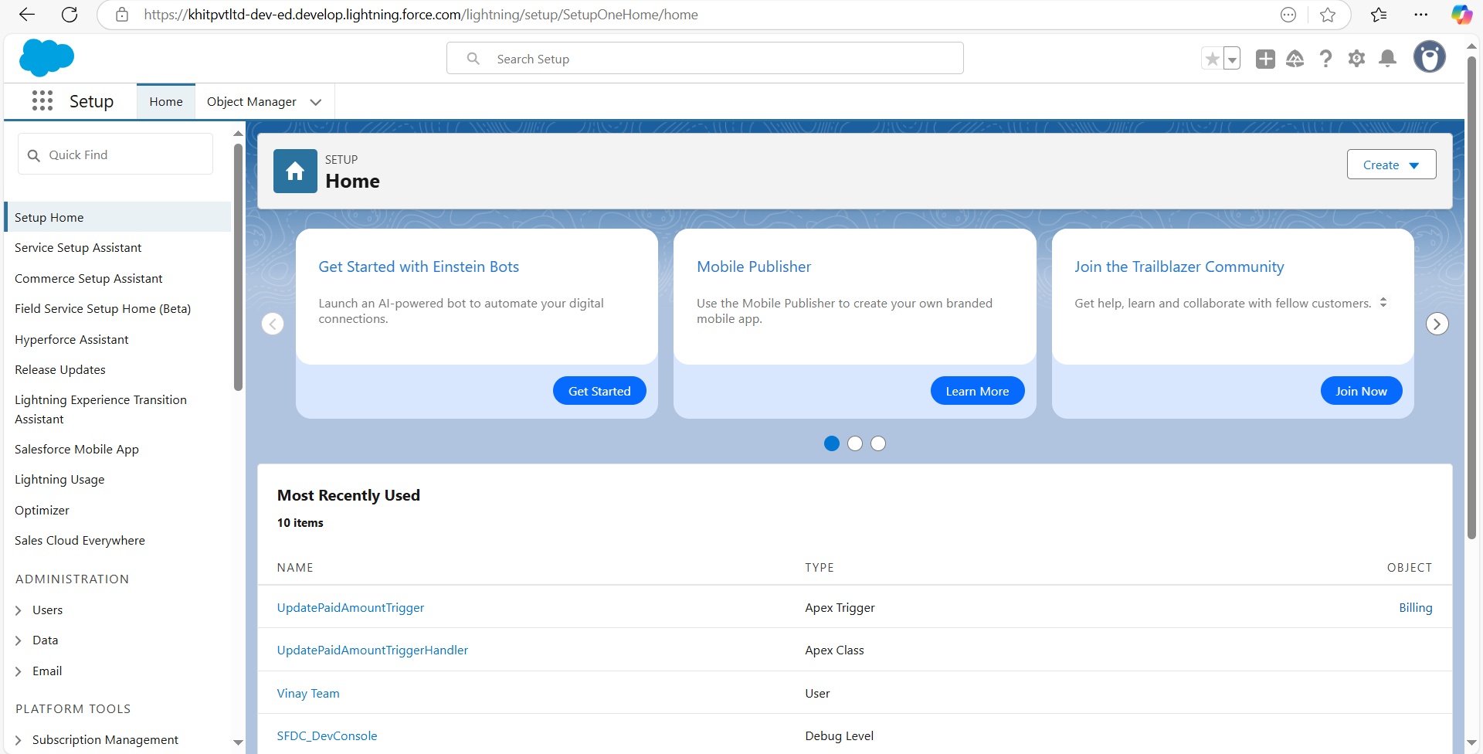

### MODULE -2. Custom object creation

The custom objects that are created are –

1. Jewel Customer object
2. Item object
3. Order object
4. Price object
5. Billing object

**To create custom object,**

Go to salesforce org and click gear icon. Then go to object manager tab

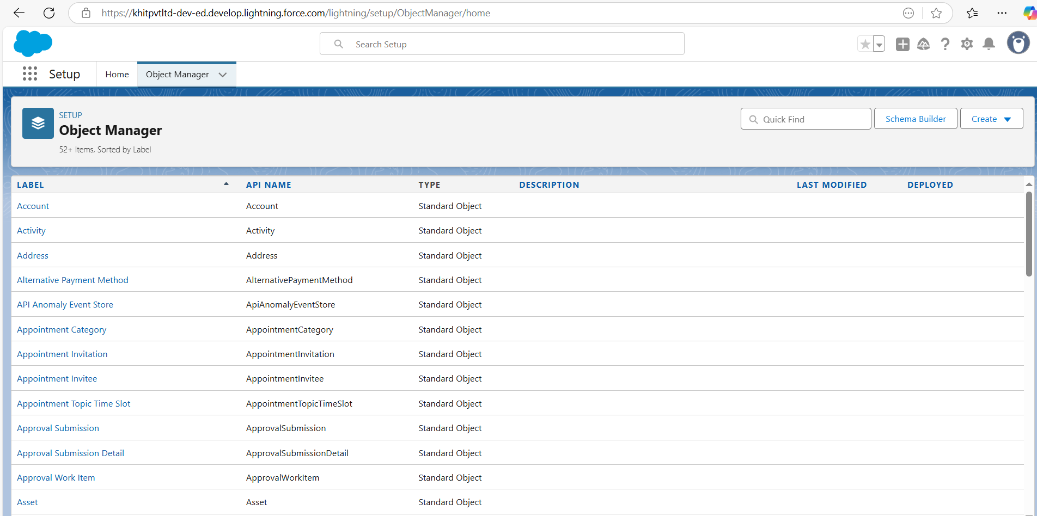

Label: Jewel Customer

1. Plural Label: Jewel Customer
2. Enter Record Name Label and Format
3. Record Name: customer name
4. Type: Text Data
5. Click on Allow Reports.
6. Save.

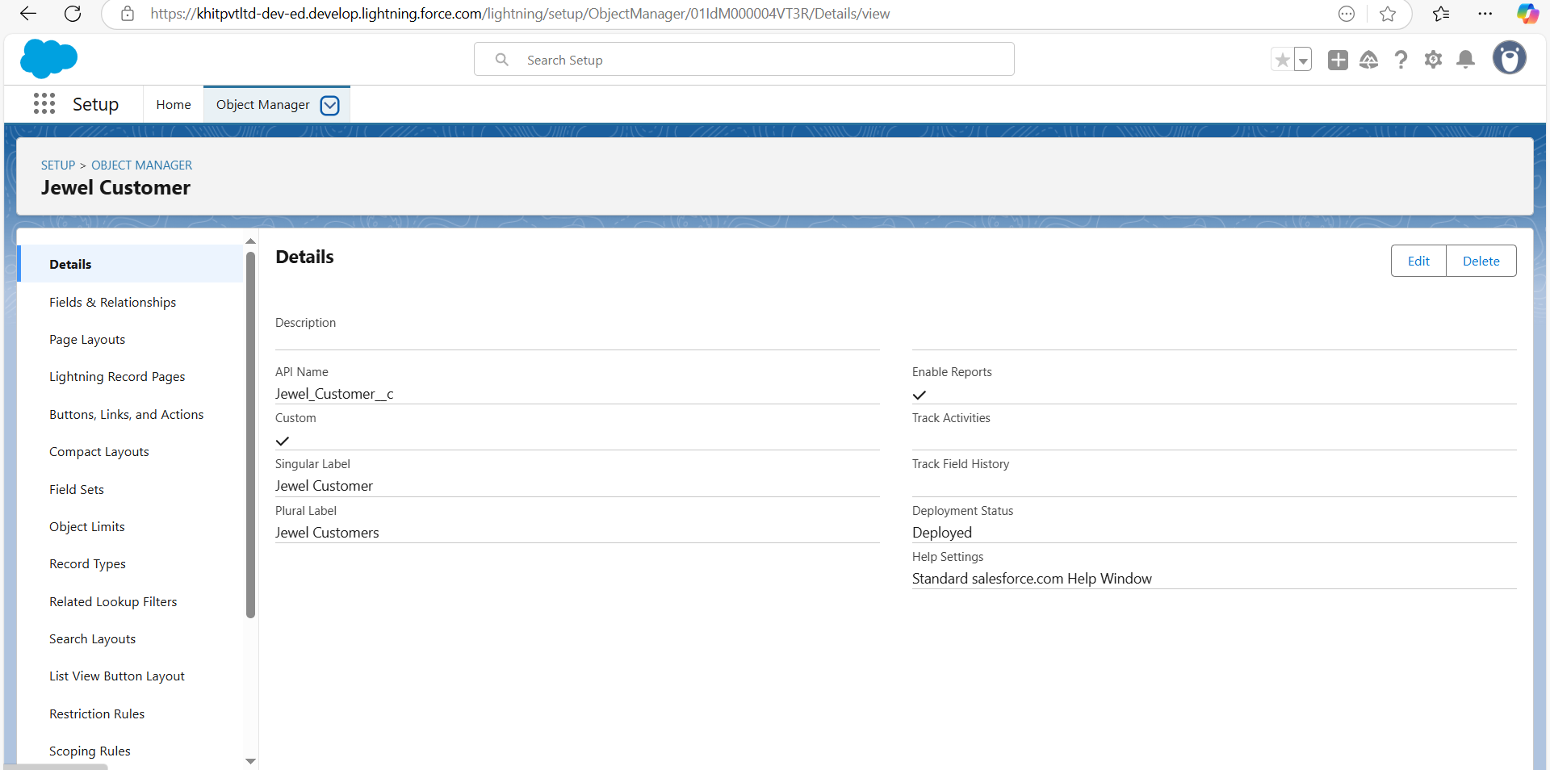

Now, repeat same steps to create Item, Order, Price, Billing Objects.

### MODULE- 3. Tabs creation

##### Creating a Custom tab:

Go to setup page

Type Tabs in Quick Find bar click on tabs

New (under custom object tab)

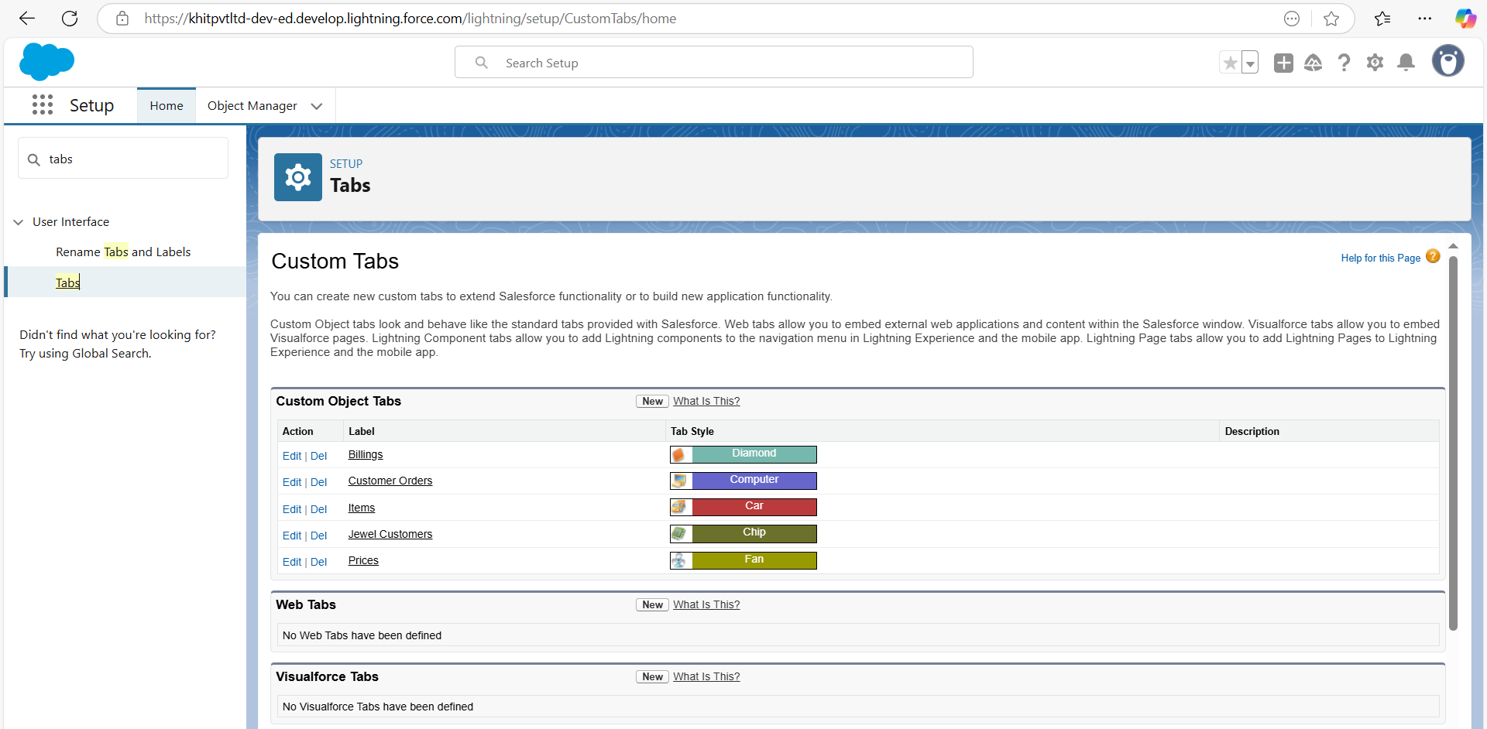

Select Object (Jewel Customer)

Select the tab style

Next (Add to profiles page) keep it as default

Next (Add to Custom App) keep it as default & save.

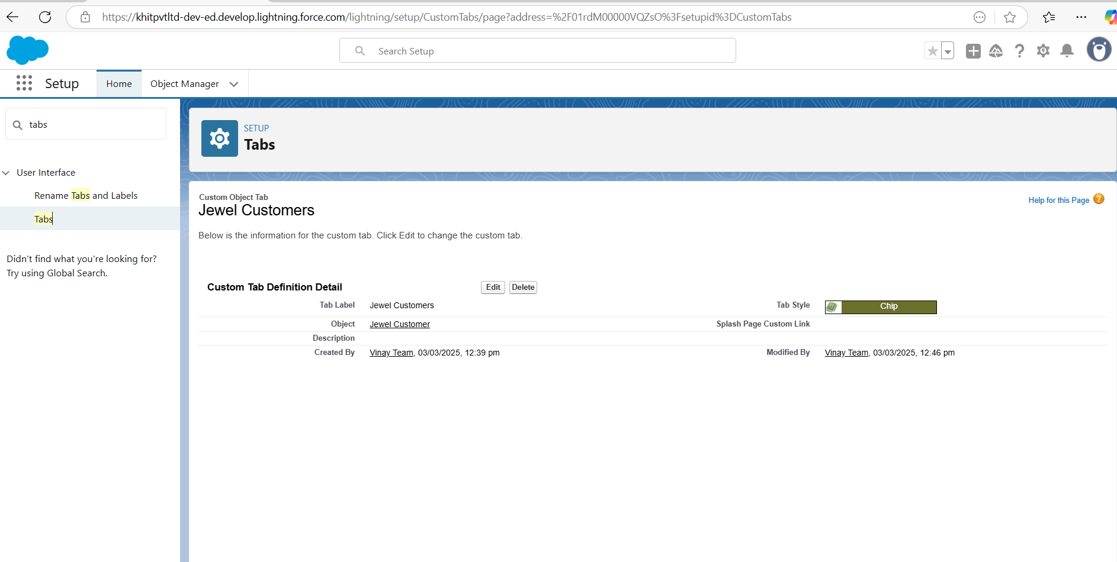

**Creating a Tab (Item):**

Go to setup page

Type Tabs in Quick Find bar

click on tabs New under custom object tab Select Object (Item)

Select the tab style

Next (Add to profiles page) keep it as default

Next (Add to Custom App) keep it as default &save.

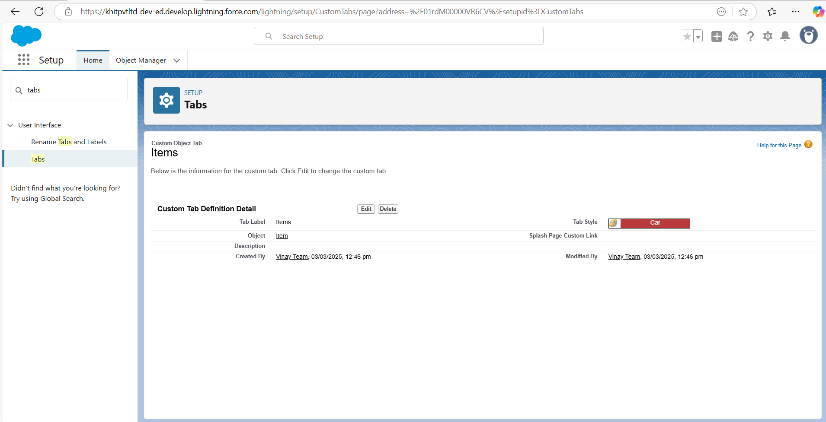

Repeat same steps for creating tabs for Customer Order, Price, Billing objects.

### MODULE- 4. Create a Lightning app

##### To create a lightning app page:

Go to set up page.

Search app manager in quick find and select app manager

Then click on “New Lightning app”

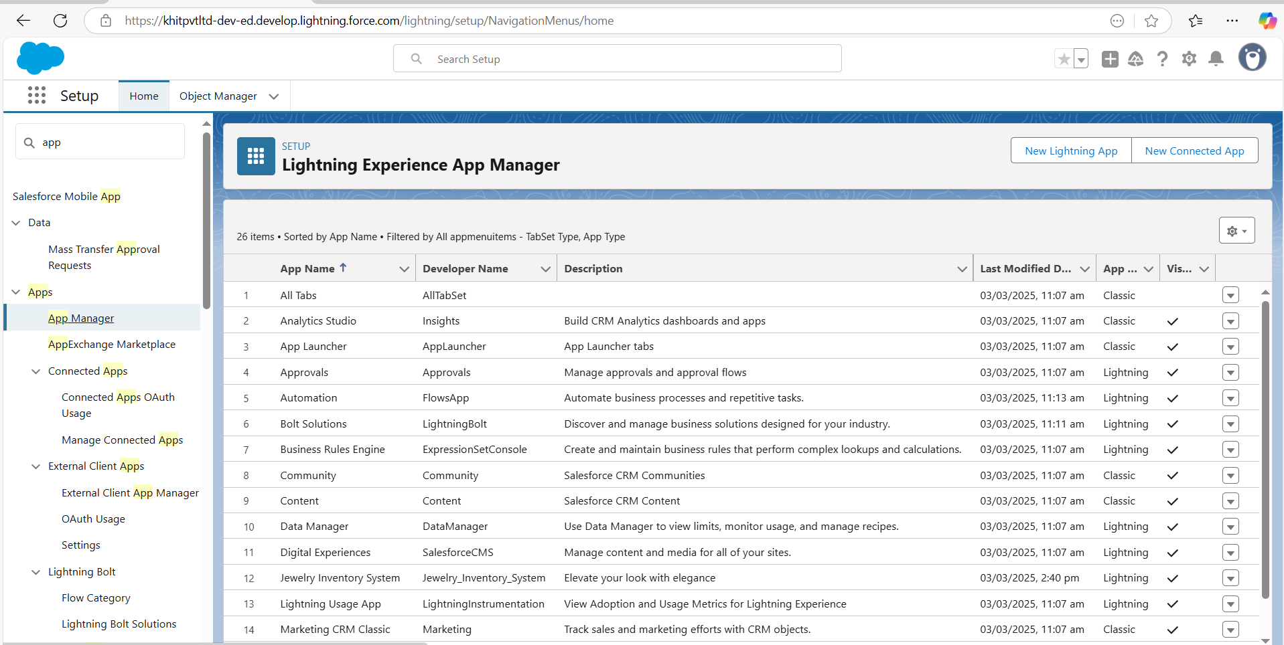

##### Fill the app name in app details and branding as follow

App Name: Jewellery Inventory System. Developer Name: This will Auto Populates. Description: Elevate your look with elegance. Image: Optional.

Primary colour Hex: keep this default. Then click Next.

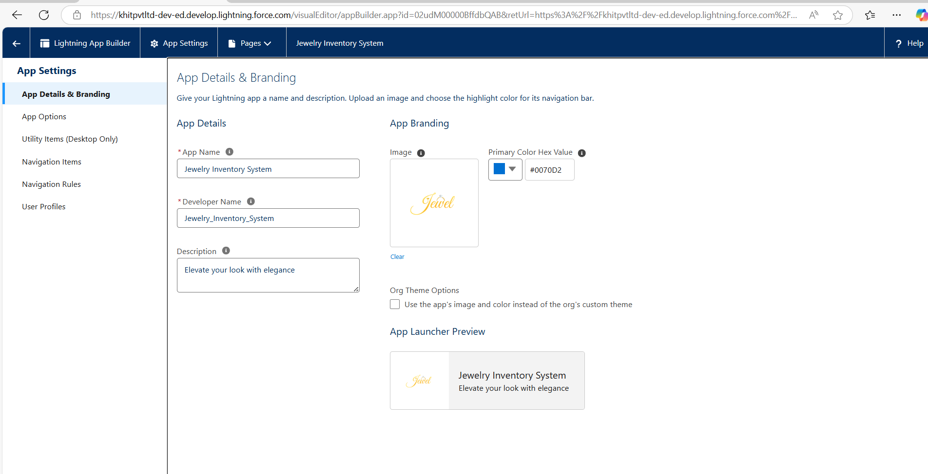

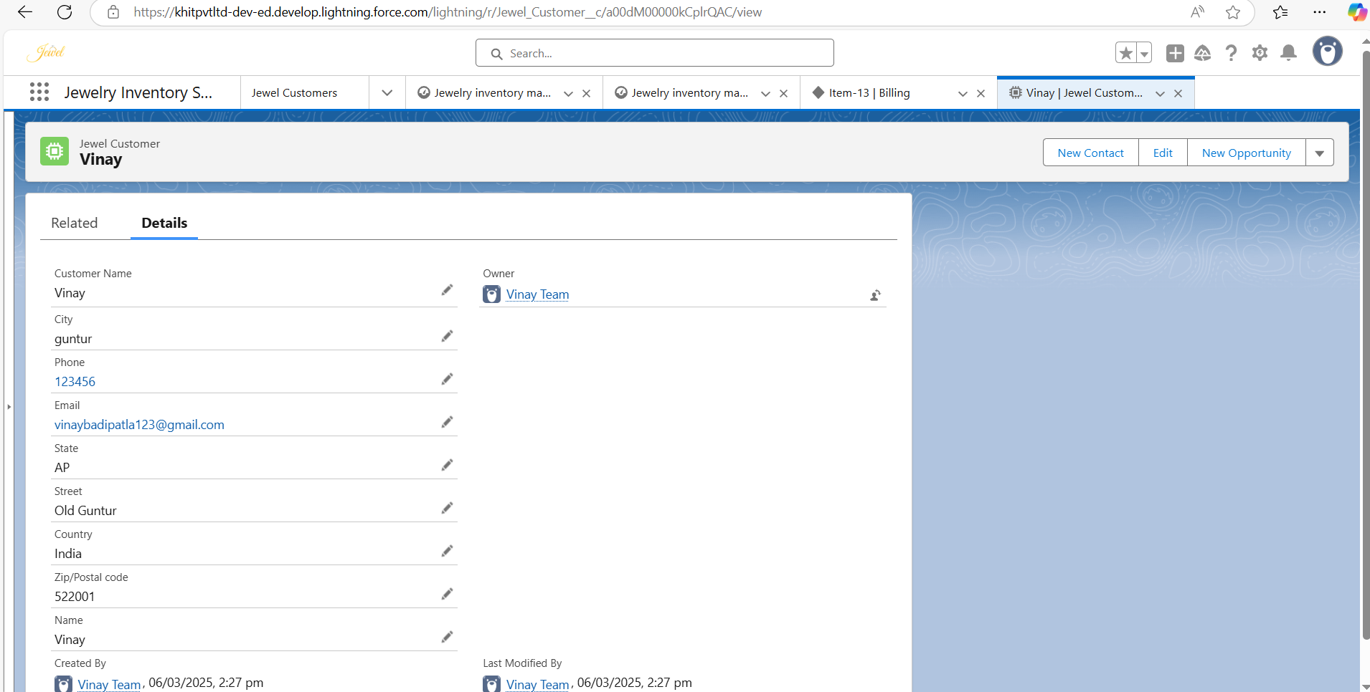

Set Navigation Style as Console Navigation &Next. To Add Navigation Items.

search for the items in the (Jewel Customer, Item, Customer Order, Price, Billing, Reports, Dashboard) from the search bar and move it using the arrow button.

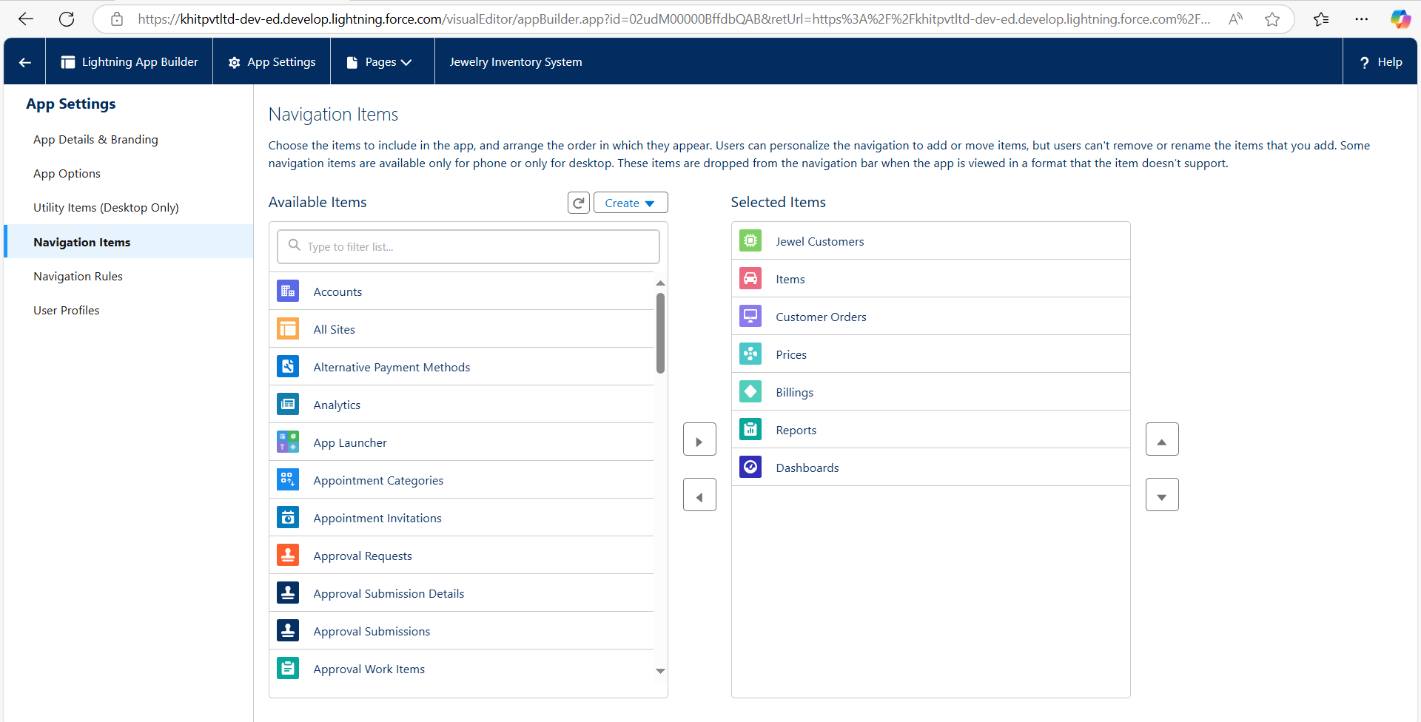

To Add User Profiles: System Administrator.

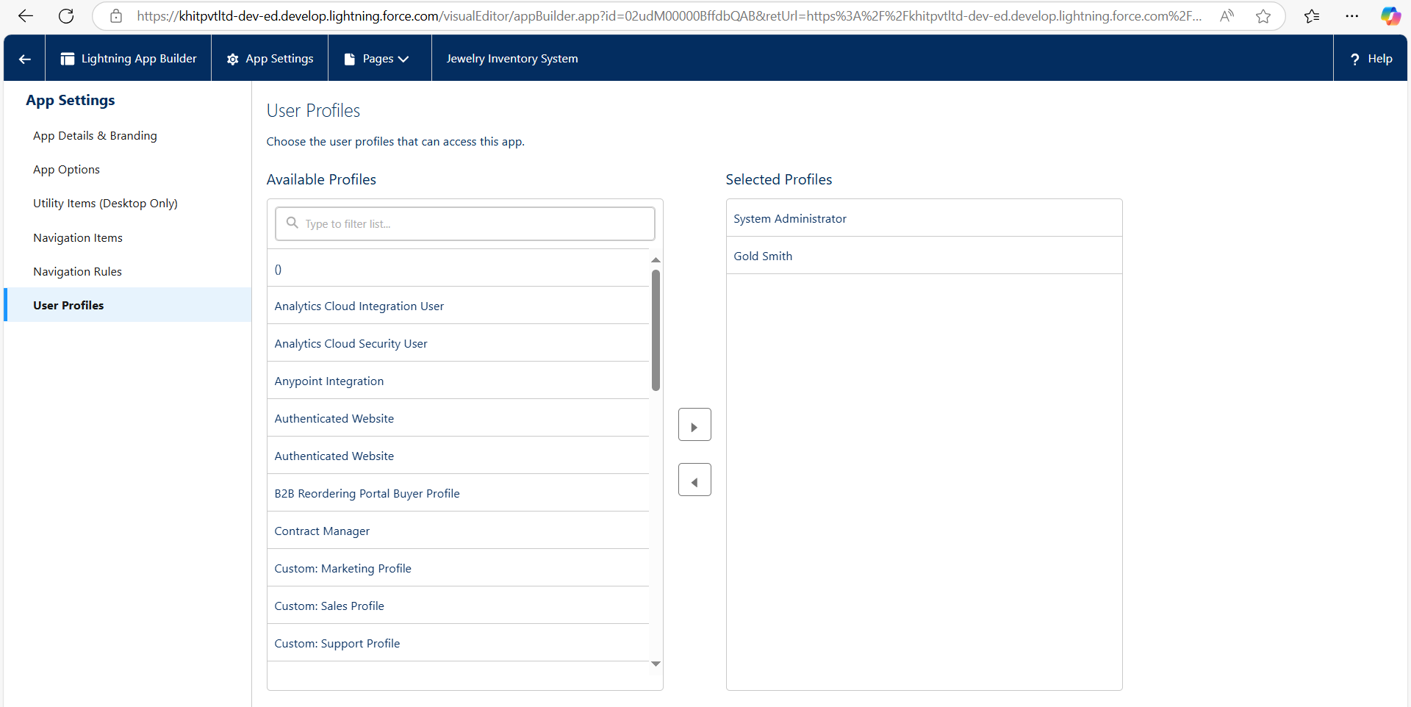.

Click Save & Finish.

### MODULE-5. Fields

In Salesforce org, click gear icon on the top left and select Setup to open Setup.

From the object manager page, In the Quick Find box, Search for the custom object you just created: Customer Order

From the sidebar, click Fields & Relationships and click new.

Creating Lookup Relationship:

1. Go to the setup page and click on object manager then type object name (Customer Order) in the quick find bar and click on the object.
2. Click on fields & relationship, click on New.
3. Select “Lookup relationship” as data type and click Next.
4. Select the related object “Jewel Customer”.
5. Give Field Label as “Customer” and click Next.
6. Next and Save.

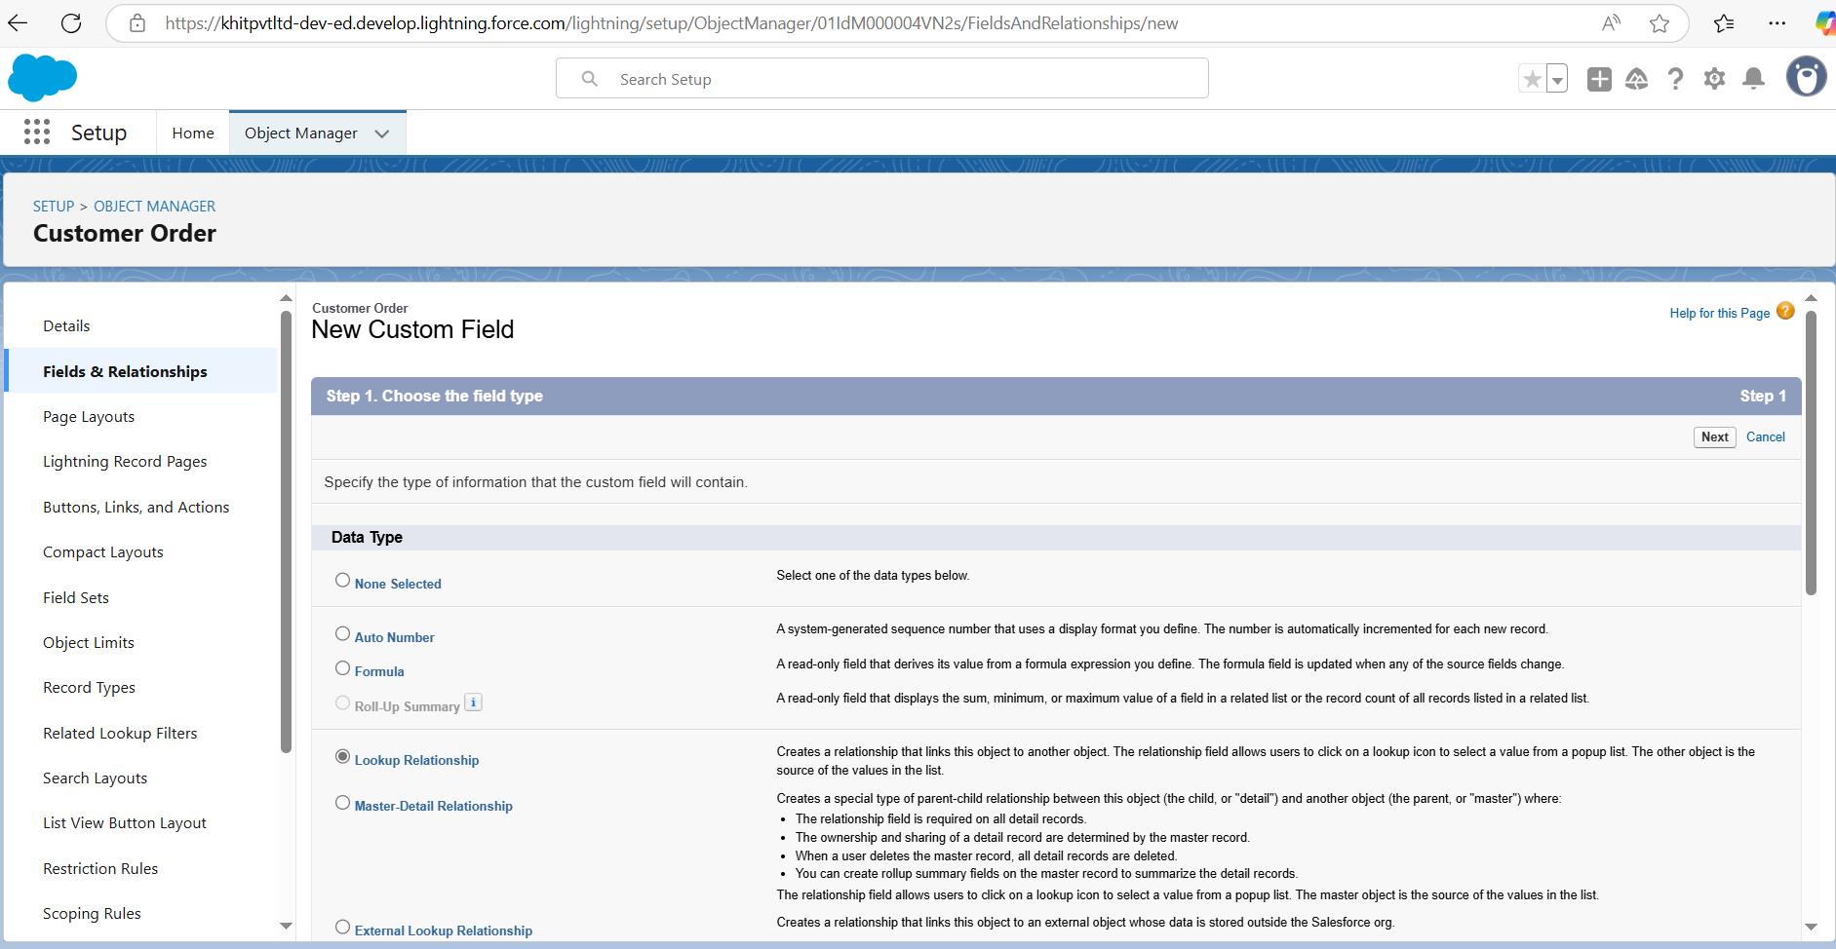

Now repeat the same for Master-Detail Relationship.

#### Creating Text Field

##### For Jewel Customer Object, Create the following fields:

1. City (Data type: Text)
2. Phone (Data type: Phone)
3. Email (Data type: Email)

##### For Item Object, Create the following fields:

1. Purity (Data type: Number)
2. Item type (Data type: Picklist) (Values: Gold, Silver)
3. Gold Price (return type: Currency) (formula: Prices r.Gold_price c /10)

##### For Price Object, Create the following fields:

1. Gold Price (Data type: Currency)

**Creating Remaining Fields in Objects:**

Now create the remaining fields using the data types mentioned.

|  |  |
| --- | --- |
| Field Name | Data type |
| State | Text (20) |
| Street | Text (20) |
| Country | Text (18) |
| Zip/Postal code | Text (6) |

|  |  |  |
| --- | --- | --- |
| s.no | Object name | Fields |
| 1 | Jewel Customer |  |

|  |  |  |
| --- | --- | --- |
| 2 | Price | Silver Price Currency  (Length=8, Decimal=5) |
| 3 | Item |  |

|  |  |
| --- | --- |
| Field Label: Customer Name | Lookup Relationship with Jewel Customer Object |
| Ornament | Text (20) |
| Weight | Number  (Length=8, Decimal=5) |
| Stone Weight | Number  (Length=5, Decimal=5) |
| Percentage | Number  (Length=2, Decimal=0) |
| Stone/Other Price | Currency  (Length=8, Decimal=2) |
| Expected Days of Return | Picklist  1-3 Days  4-5 Days  6-7 Days  8-10 Days |
| Priority | Picklist  Low Medium High Critical |
| Silver Price | Formula (Return Type: Number) (Decimal=3) |

|  |  |  |
| --- | --- | --- |
|  |  |  |
| 4 | Customer Order | Order Status Picklist  Started Not Started On Hold Completed  Not Completed |

|  |  |
| --- | --- |
|  | (Prices r.Silver_price c / 1000) |
| Purity Gold Price | Formula (Return Type: Currency) (Decimal=2)  ((Prices r.Gold_price c* Purity_c ) / 24) / 10 |
| Total Weight | Formula (Return Type: Number) (Decimal=3) (Weight c - Stone_weight c) |
| Amount | Formula (Return Type: Currency) (Decimal=3)  IF(ISPICKVAL( Item_Type c ,"Gold"), Total_weight c * Purity_Gold_price c , Total_weight c * Silver_price c ) |
| KDM | Formula (Return Type: Currency) (Decimal=0) (Amount c * Percentage c ) / 100 |
| Making Charges | Formula (Return Type: Currency) (Decimal=0)  IF(ISPICKVAL((Item_Type c,"Gold"), Weight c * 300 , Weight c * 10 ) |

5 Billing

|  |  |
| --- | --- |
| Field Label: Item | Lookup Relationship with Item Object |
| Ornament | Formula (Return Type: Text) Item r.Ornament c |
| Stone weight | Formula (Return Type: Number) (Decimal=2) Item r.Stone_weight c |
| Weight | Formula Return Type: Number (Decimal=2) Item r.Total_weight c |
| Amount | Formula (Return Type: Currency) (Decimal=2) Item r.Amount c |
| Gold/Silver Price | Formula (Return Type: Currency) (Decimal=2)  IF(ISPICKVAL( Item r.Item_Type c",Gold"), Item r.Gold_price c , Item r.Silver_price c ) |
| KDM Charge | Formula (Return Type: Currency) (Decimal=0) Item r.KDM c |
| Making Charges | Formula (Return Type: Currency) (Decimal=2) Item r.Making_Charges c |
| Stones/other price | Formula (Return Type: Currency) (Decimal=2) Item r.Stone_other_price c |
| Total Amount | Formula (Return Type: Currency) (Decimal=0)  Amount c +KDM_Charge c + Stones_other  _price c + Making_Charges c |

##### Schema Builder:

1. Go to setup
2. Click on object manager
3. Schema Builder

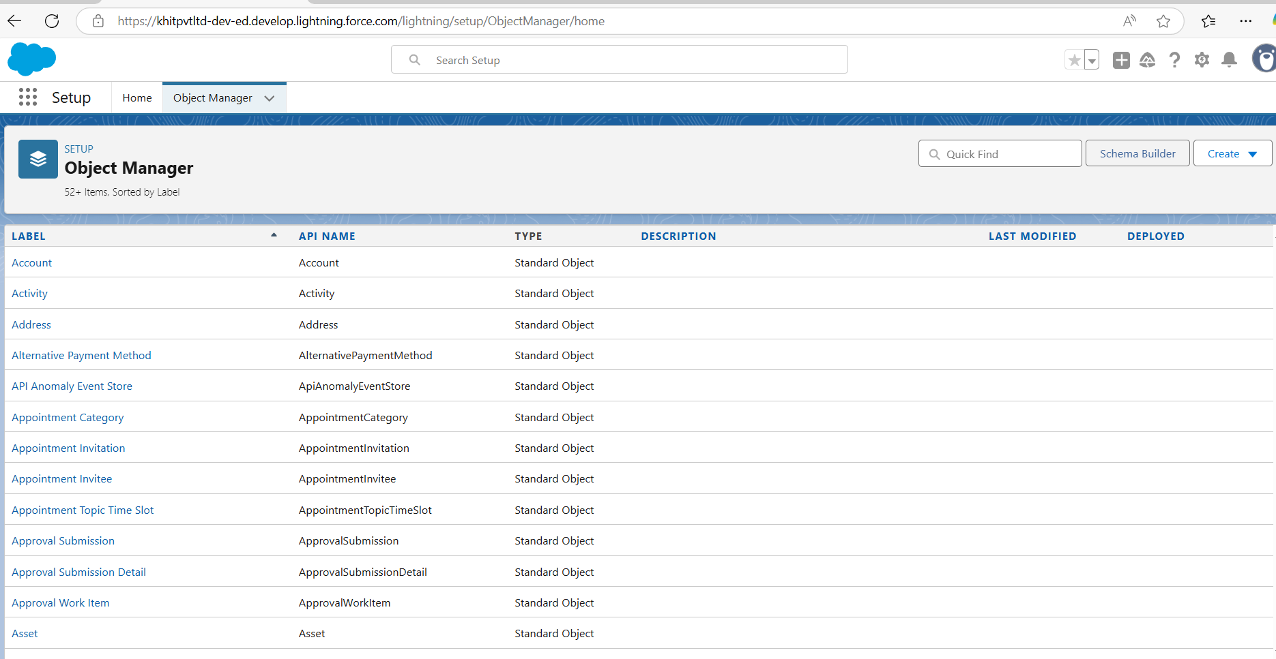

1. Select objects then Enter Objects as “Jewel Customer, Item, Customer Order, Price, Billing objects” in quick box and select them.

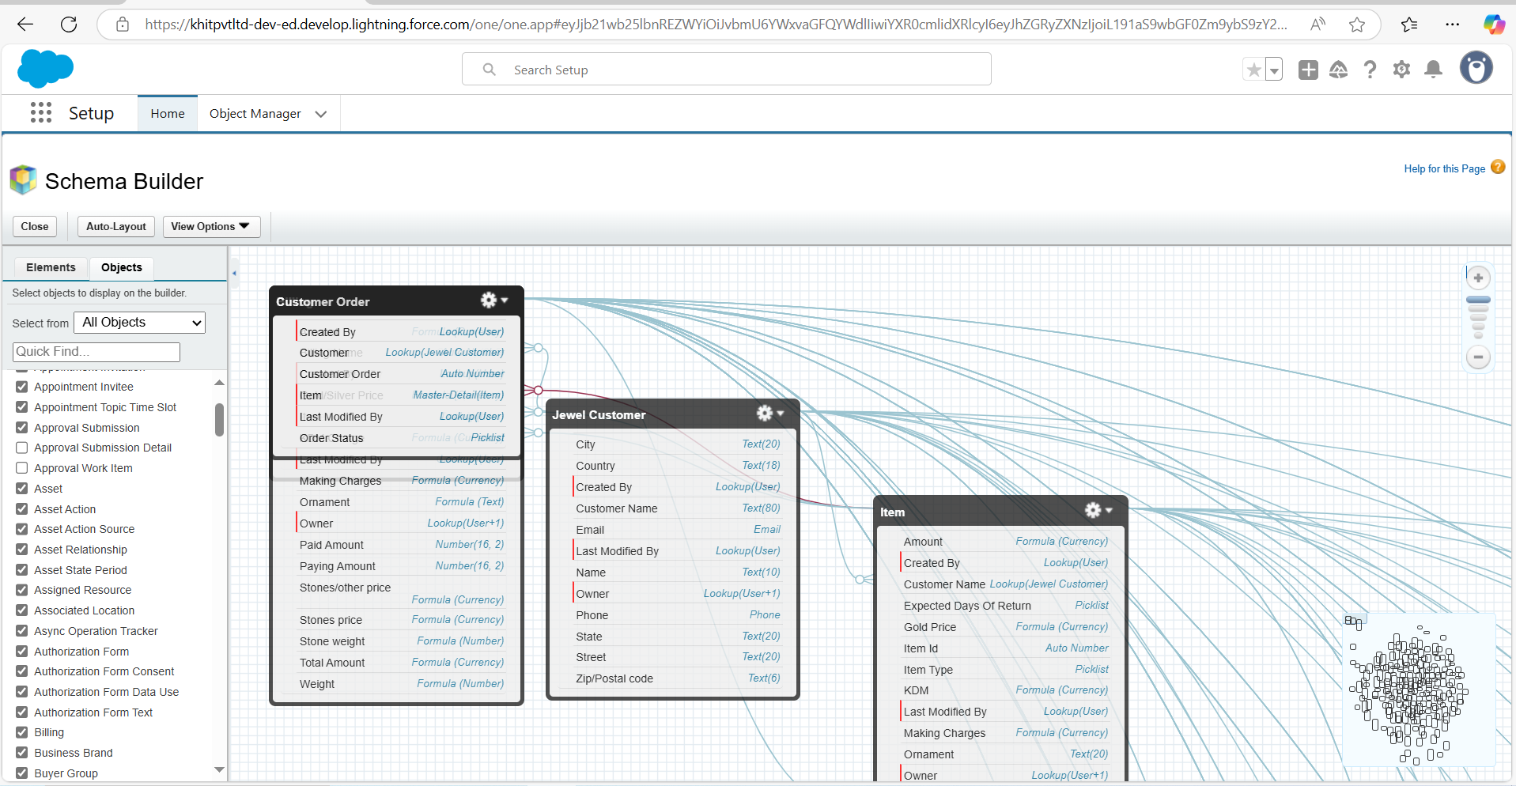

##### Creating the field Dependencies:

1. Go to setup and click on Object Manager then type object name (Item) in quick find bar and click on the object.
2. Click on Fields & Relationships and click on the Priority field. Search for Field Dependencies and click on New.

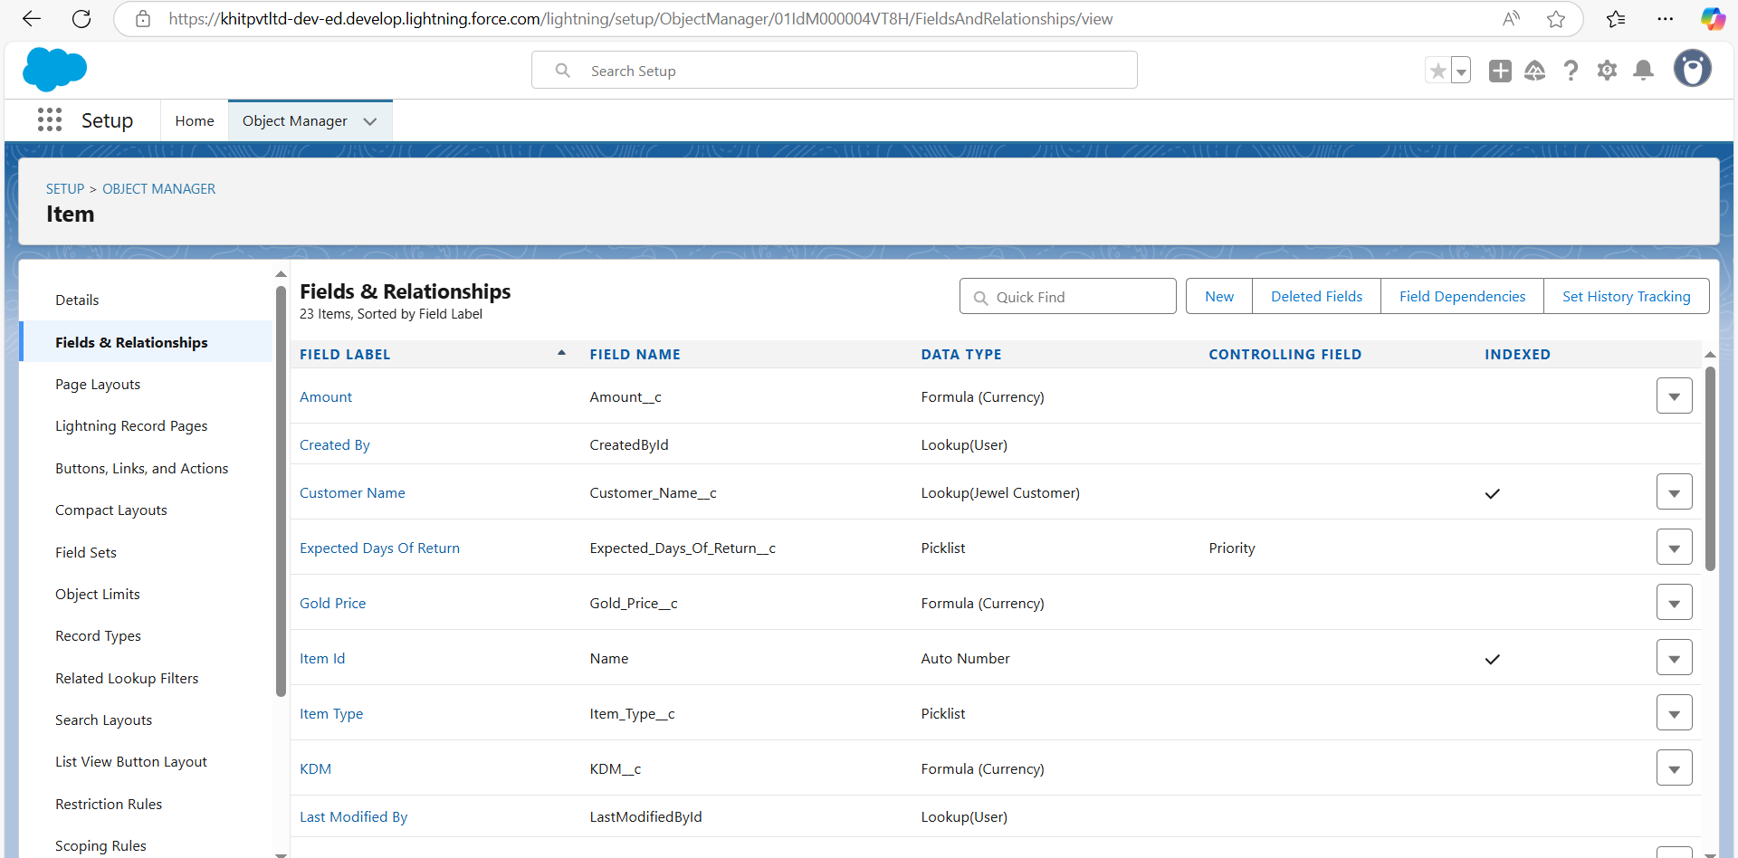

1. Select Controlling Field as “Priority” and Depending field as “Expected Days of Return” then continue.

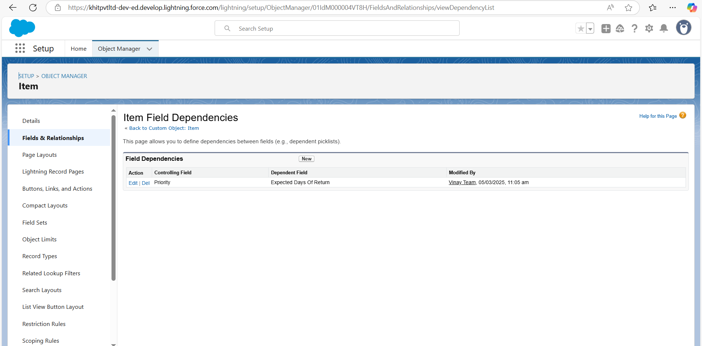

1. Select the “Expected Days of Return” values of related Priority values and Click on Include Values and Save.

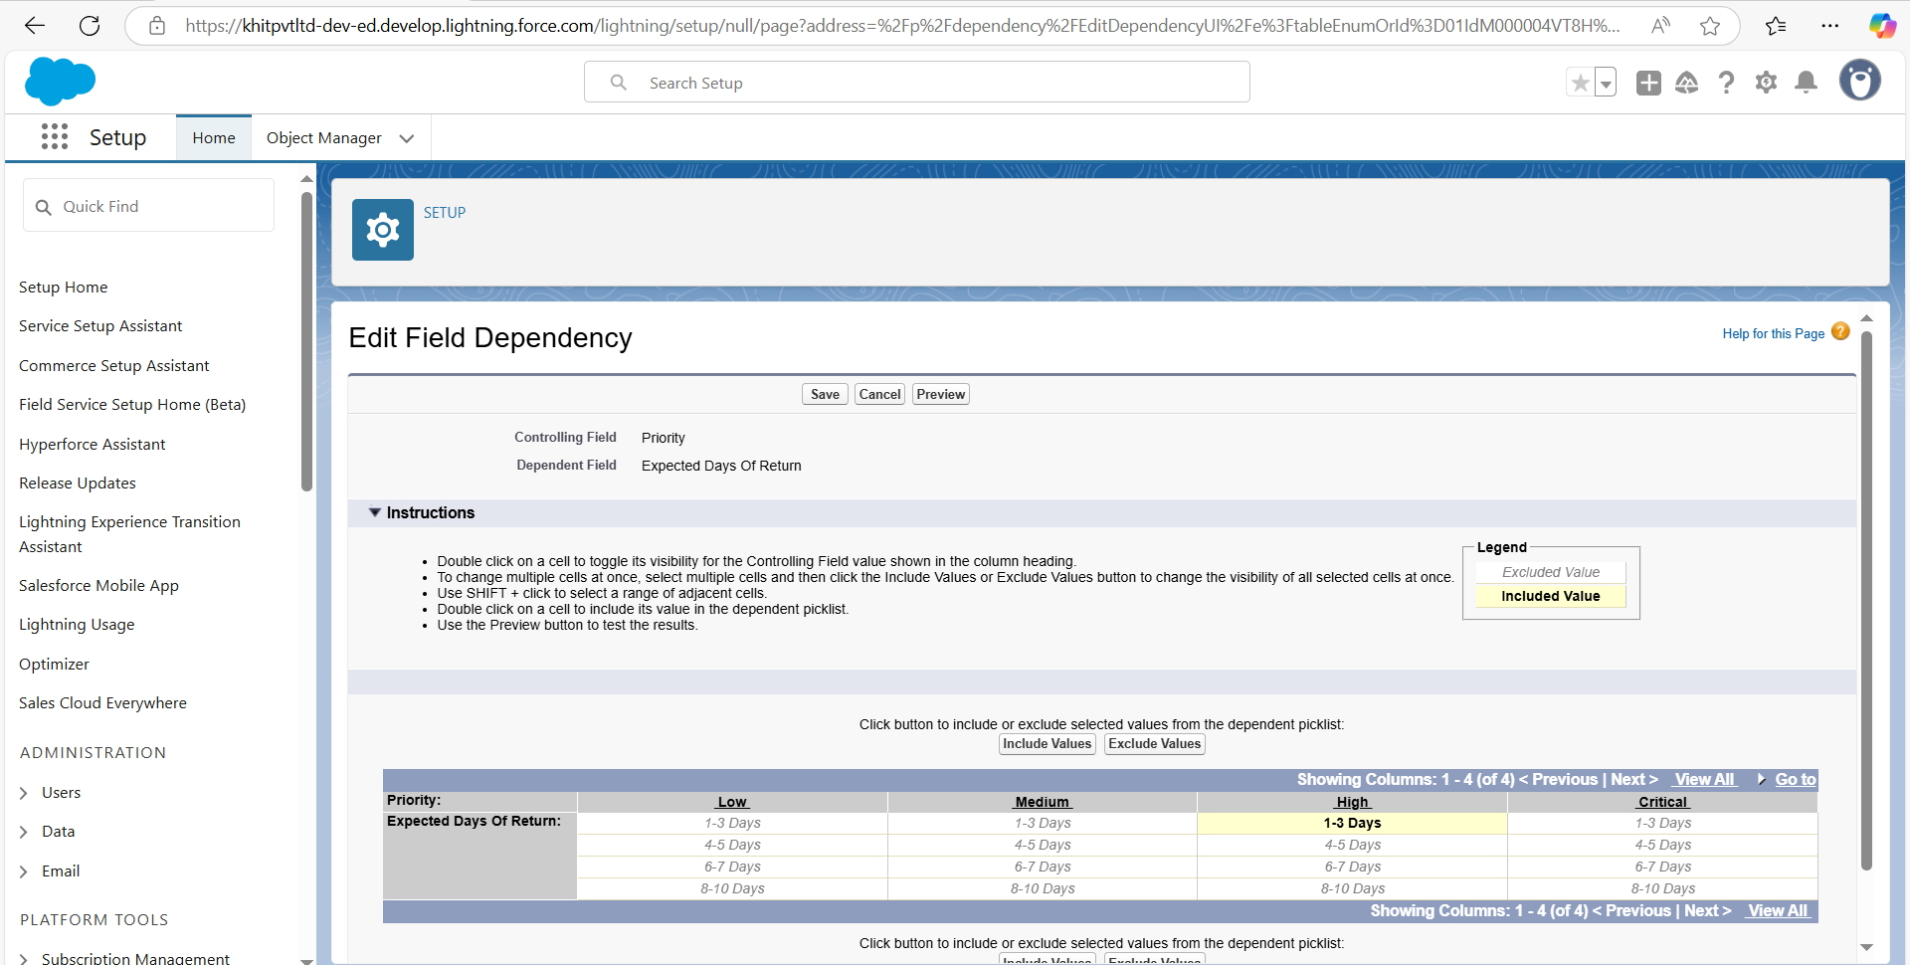

##### Creating the validation rule:

###### To create the validation rules, go to object manager tab and select Jewel Customer object.

1. Then click on validation rules. Click new.
2. Enter the Rule name as “Postal Code”.

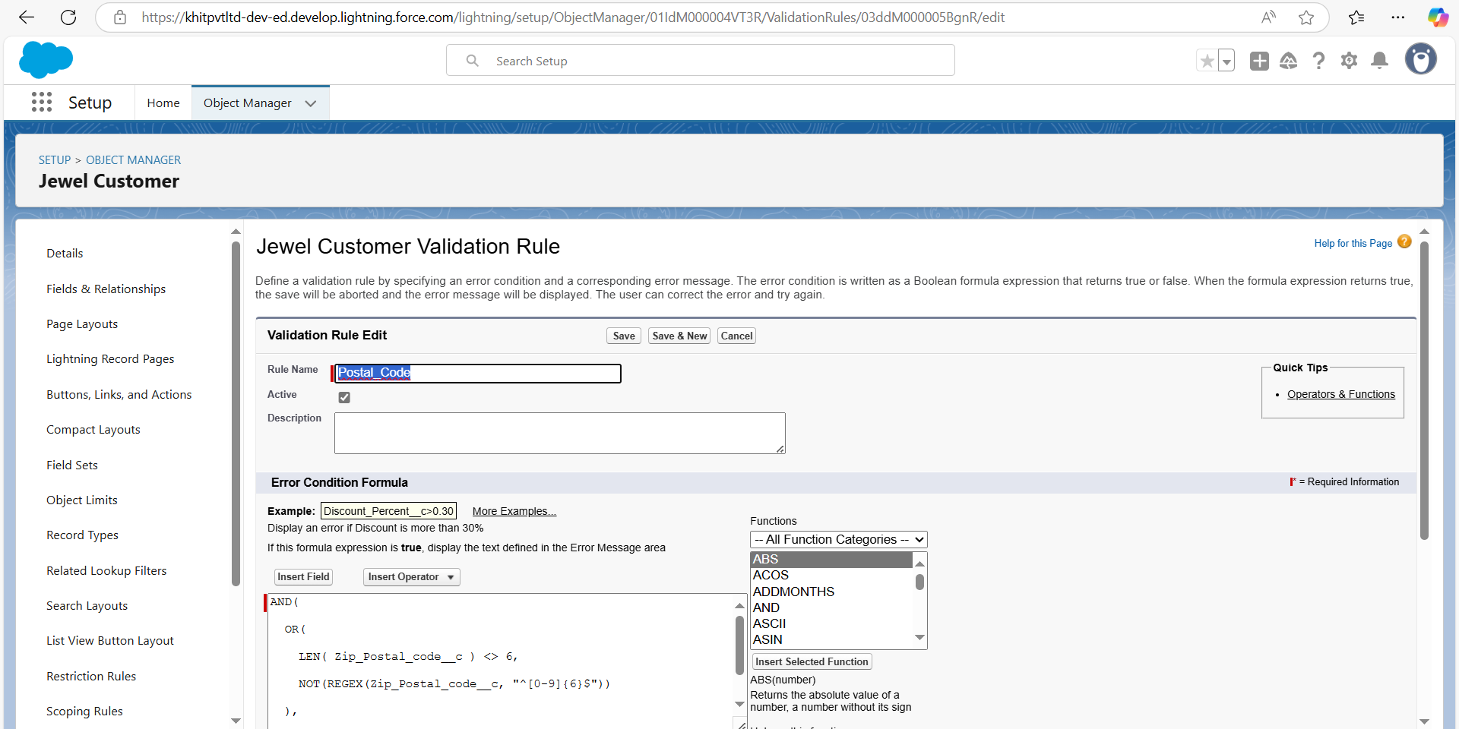

1. Insert the Error Condition Formula as: -

AND( OR(

LEN( Zip_Postal_code c ) <> 6, NOT(REGEX(Zip_Postal_code c, "^[0-9]{6}$"))

),

NOT(ISBLANK(Zip_Postal_code c)))

1. Also enter the error message as shown below.
2. Now create one more validation rule for jewel customer object.
3. Enter Rule name as “Validation Rule for Jewel Customer Object “.

Insert the Error Condition Formula as: -

“OR( ISBLANK( City c ) , ISBLANK( Country c ),ISBLANK( Phone c ),ISBLANK ( State c ),ISBLANK( Street c ) )”

1. Enter the Error Message as “Please fill Required fields”, select the Error location as Top of Page and click Save.

Create Validation rule for Item object.

Enter Rule name as “Validation Rule for Item”.

Insert the Error Condition Formula as: -

OR(ISBLANK( Amount c ) , ISBLANK( Customer_Name c ) ,ISBLANK( Gold_price c ),ISBLANK( KDM c ),ISBLANK( Ornament c ),ISBLANK( Percentage c ),ISBLANK( Making_Charges c ),ISBLANK( Prices c ),ISBLANK( Stone_weight c ),ISBLANK( Silver_price c ),ISBLANK( Stone_other_price c

),ISBLANK( Stone_weight c ),ISBLANK( Weight c ))

Enter the Error Message as “Please fill Required fields”, select the Error location as Top of Page and click Save.

### MODULE-6. Profile

A profile is a group/collection of settings and permissions that define what a user can do in salesforce. Profile controls “Object permissions, Field permissions, User permissions, Tab settings, App settings, Apex class access, Visualforce page access, Page layouts, Record Types, Login hours & Login IP ranges. You can define profiles by the user's job function. For example System Administrator, Developer, Sales Representative.

##### Types of profiles in salesforce

**1.Standard profiles:**

By default, salesforce provides below standard profiles.

1. Contract Manager
2. Read Only
3. Marketing User
4. Solutions Manager
5. Standard User
6. System Administrator.

We cannot deleted standard ones

Each of these standard ones includes a default set of permissions for all of the standard objects available on the platform.

* 1. Custom Profiles:

Custom ones defined by us.

They can be deleted if there are no users assigned with that particular one.

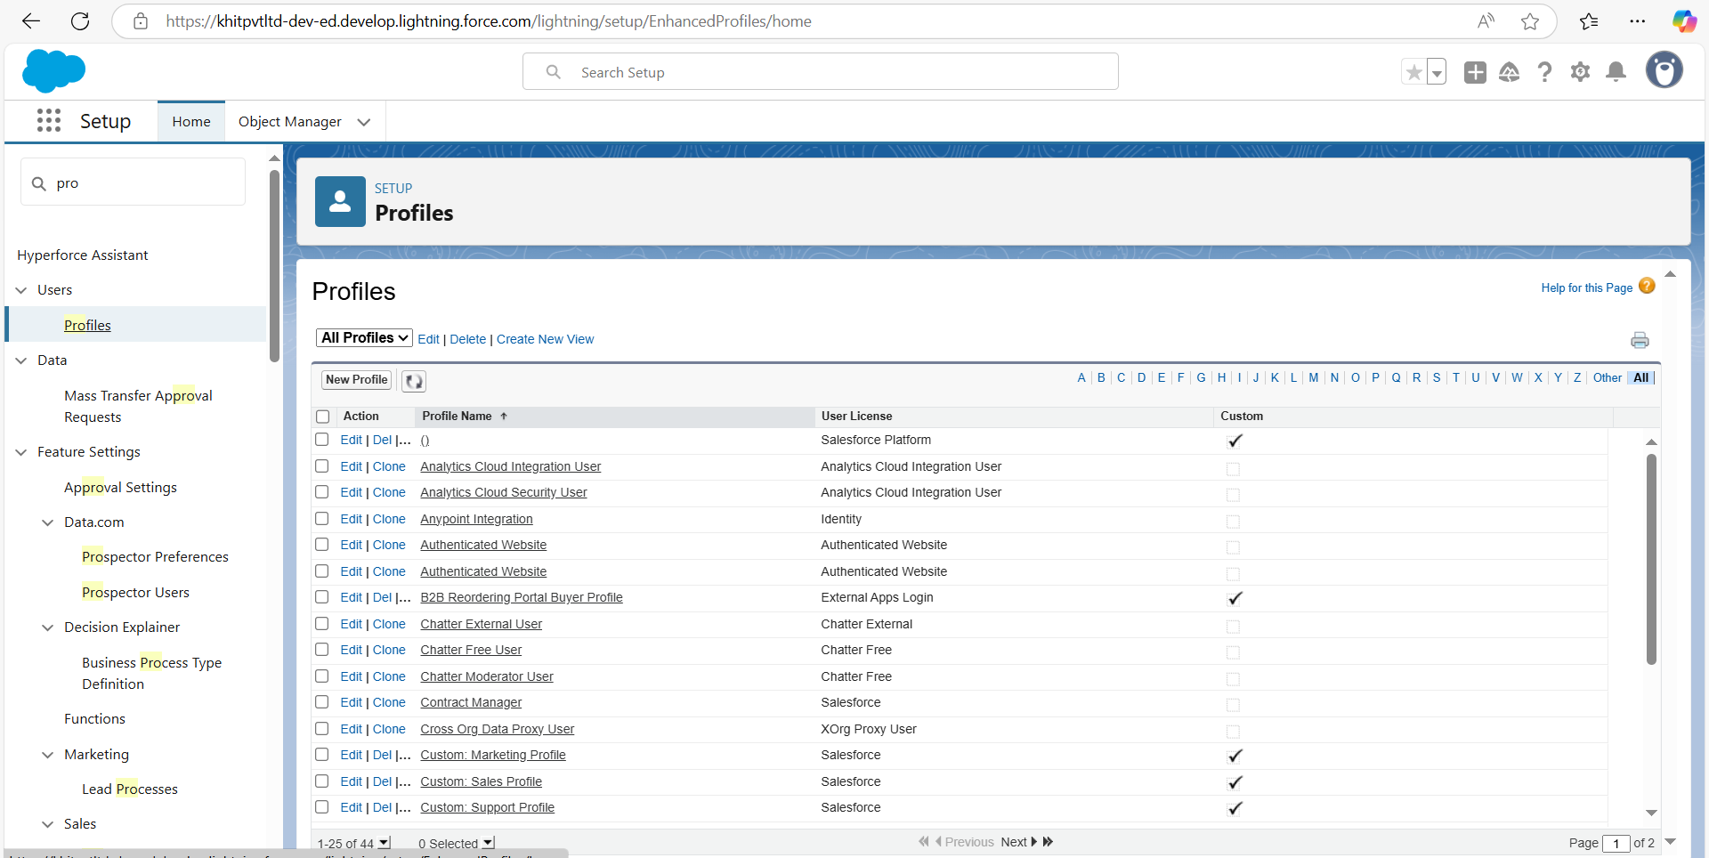

# Gold Smith Profile

##### Navigate to Setup

Access the Setup menu by clicking on the gear icon (HO•) usually located in the upper right-hand corner of the screen.

##### Find Profiles

In the Quick Find box on the left-hand side, type profiles. Click on the Profiles link that appears in the search results.

##### Clone System Administrator Profile

In the Profiles list, locate the System Administrator profile. Click on the Clone action next to it.

A dialog box will appear. Enter Gold Smith as the new profile name. Click on Save to create the new profile.

##### Edit the "Gold Smith" Profile

After saving, you will be redirected to the profile page for Gold Smith**.** Click on the Edit button at the top of the page.

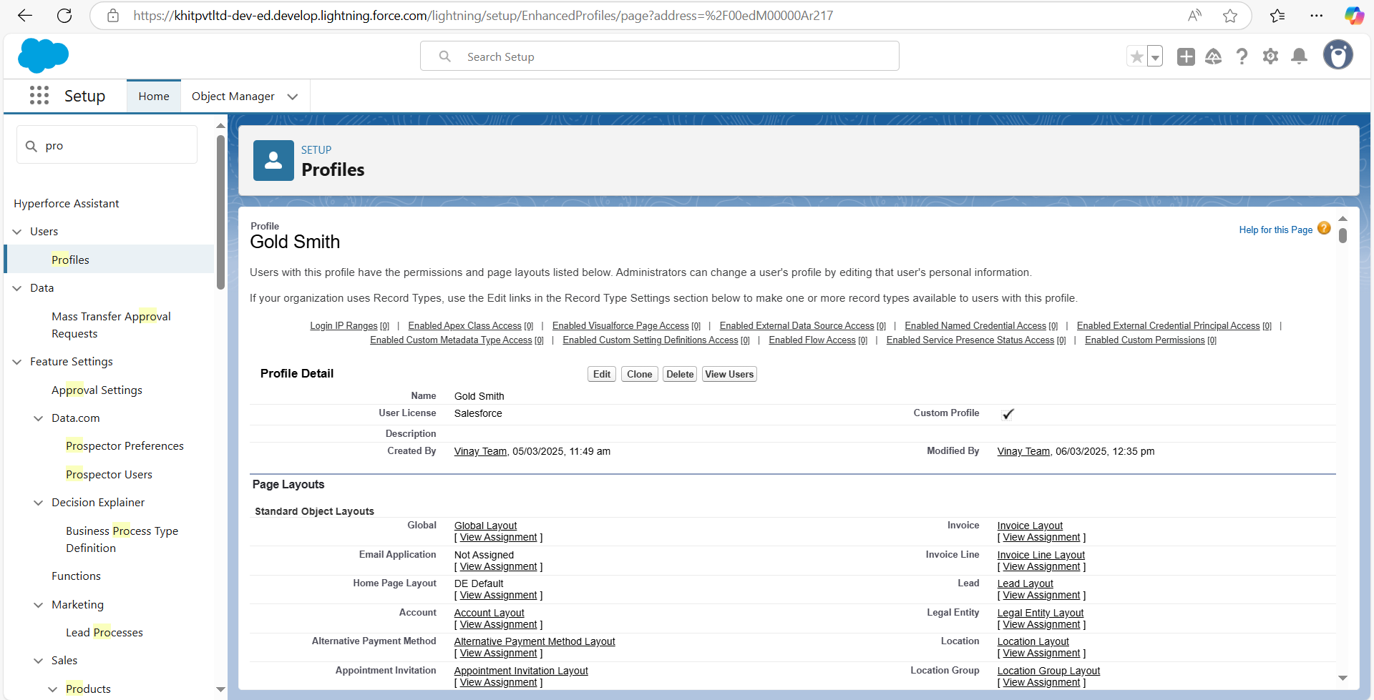

##### Set Custom Object Permissions

Scroll down the profile page to the Custom Object Permissions section. For each of the following objects, set the appropriate access permissions:

**Jewel Customer**: Assign desired access permissions (e.g., Read, Create, Edit, Delete).

**Item**: Assign desired access permissions.

**Customer Order**: Assign desired access permissions.

**Prices**: Assign desired access permissions.

**Billings**: Assign desired access permissions.

##### Save the Profile

Once all permissions are set, scroll down to the bottom of the page. Click on the Save button to apply the changes.

# Worker Profile

##### Navigate to Setup

Access the Setup menu by clicking on the gear icon (HO•) usually located in the upper right-hand corner of the screen.

##### Find Profiles

In the Quick Find box on the left-hand side, type profiles. Click on the Profiles link that appears in the search results.

##### Clone Salesforce Platform User Profile

In the Profiles list, locate the Salesforce Platform User profile. Click on the Clone action next to it.

A dialog box will appear. Enter Worker as the new profile name. Click on Save to create the new profile.

##### Edit the "Worker" Profile

After saving, you will be redirected to the profile page for Worker. Click on the Edit button at the top of the page.

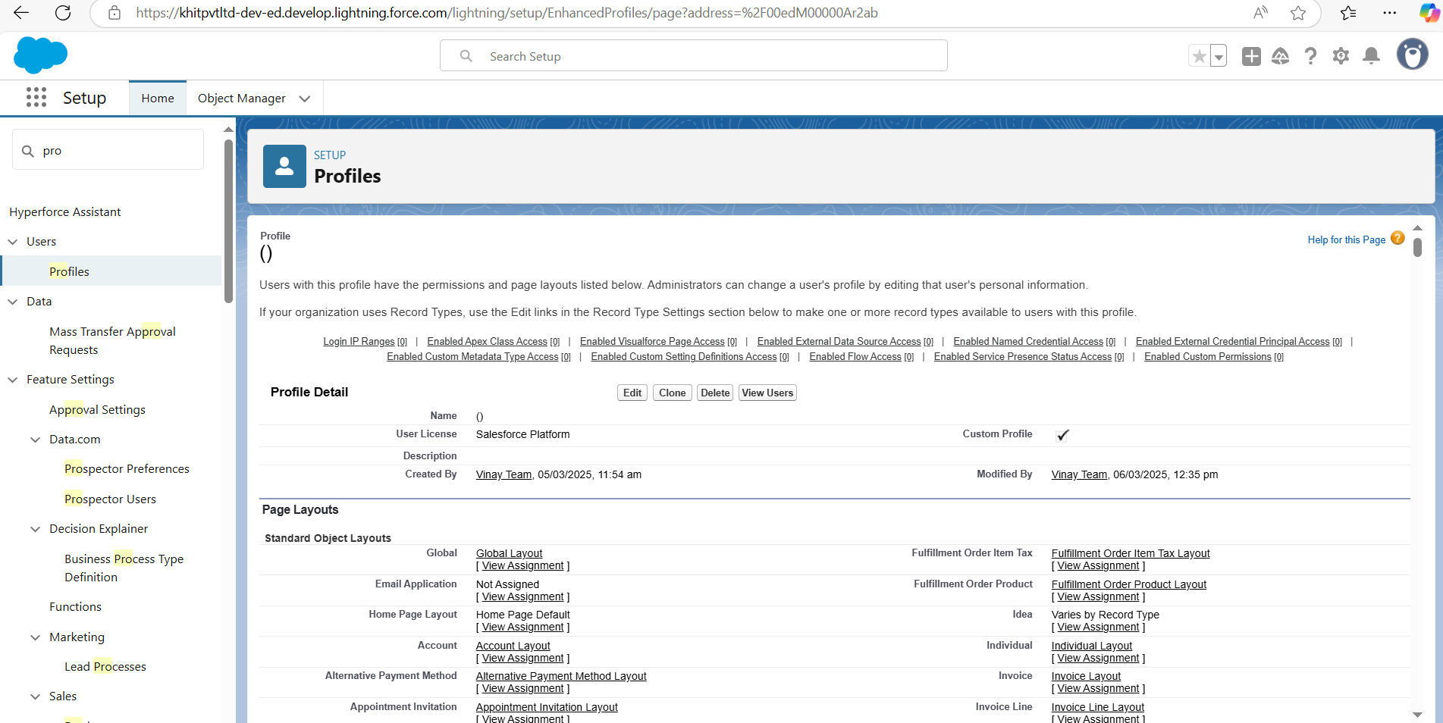

##### Set Custom Object Permissions

Scroll down the profile page to the Custom Object Permissions section. For each of the following objects, set the appropriate access permissions:

**Items**: Assign desired access permissions (e.g., Read, Create, Edit, Delete).

**Price**: Assign desired access permissions.

**Customer Order**: Assign desired access permissions.

##### Save the Profile

Once all permissions are set, scroll down to the bottom of the page. Click on the Save button to apply the changes.

### MODULE-7. Roles

A role in Salesforce defines a user's visibility access at the record level. Roles may be used to specify the types of access that people in your Salesforce organisation can have to data. Simply put, it describes what a user could see within the Salesforce organisation.

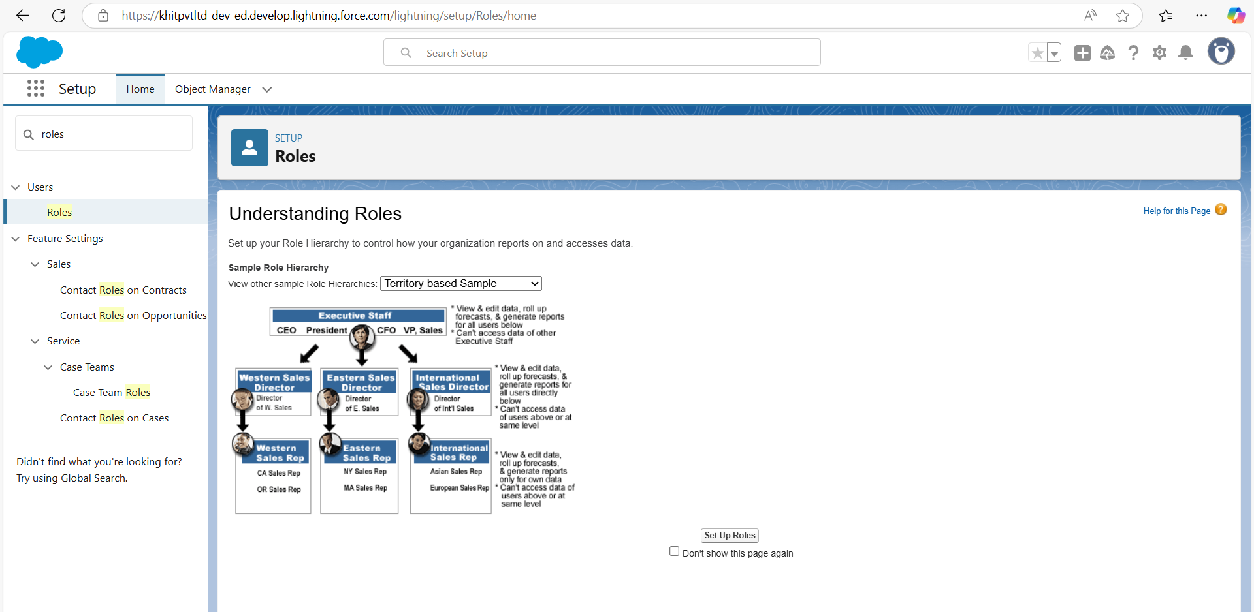

**Creating Gold Smith Role**

##### Navigate to Setup

Access the Setup menu by clicking on the gear icon (•H•HO) usually located in the upper right-hand corner of the screen.

##### Search for Roles

In the Quick Find box on the left-hand side, type roles.

Click on the Set Up Roles link that appears in the search results.

* 1. Expand Roles Hierarchy

On the Roles page, click on the Expand All button to view the full hierarchy of roles.

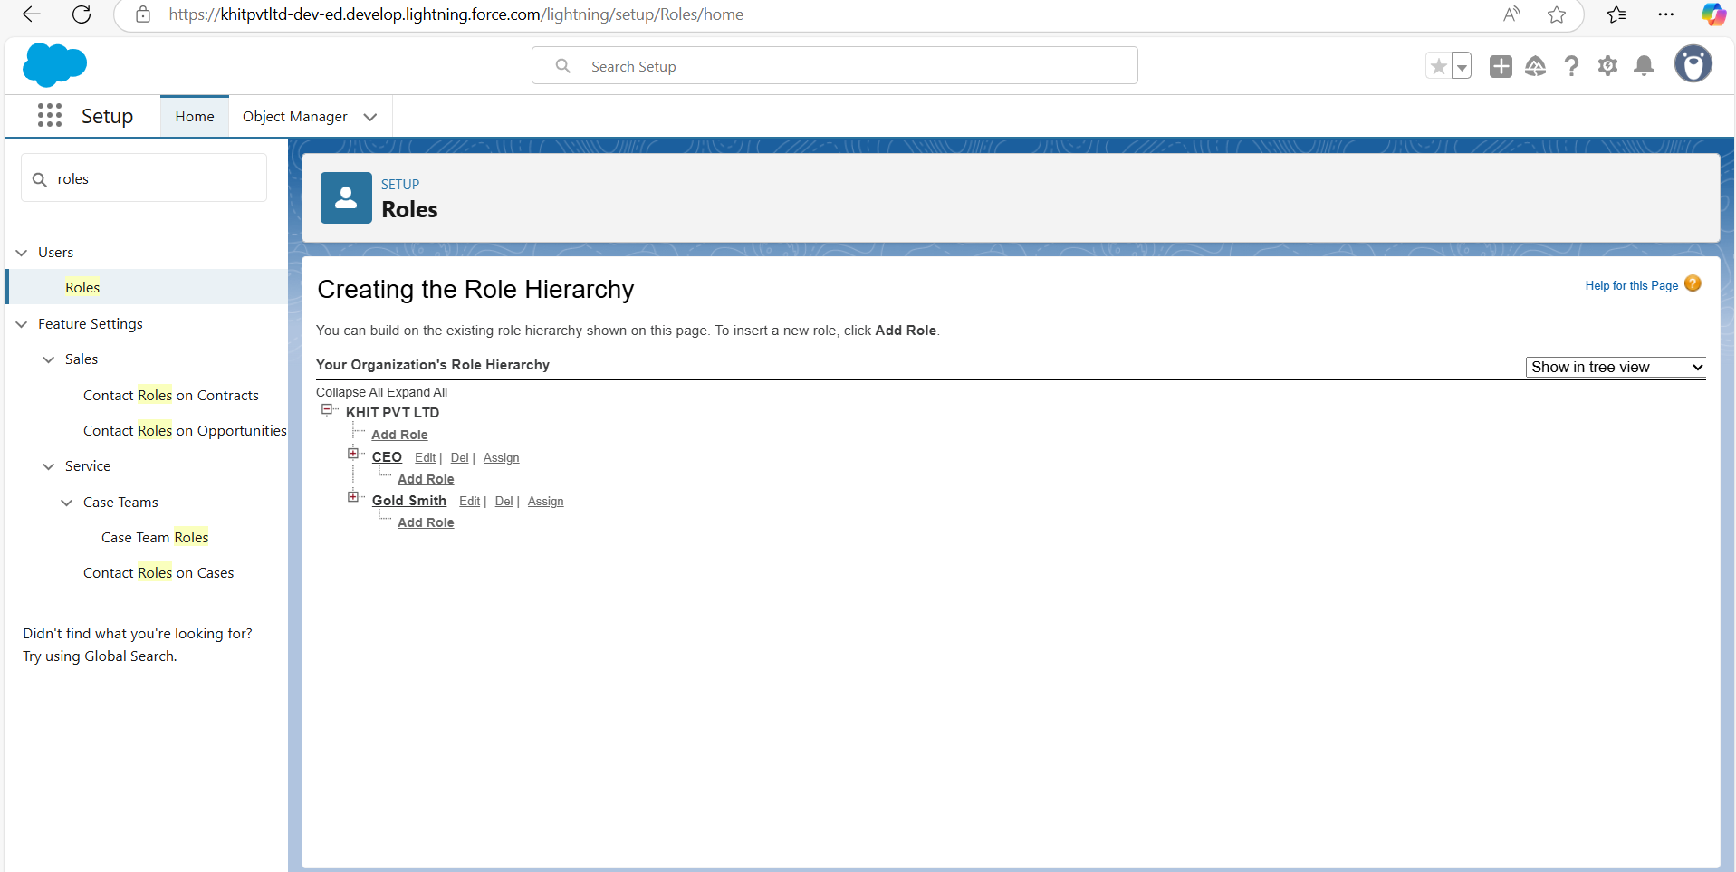

##### Add New Role

Under the role to which the "Gold Smith" role will report, click on the Add Role button.

##### Configure the New Role

**Label**: Enter Gold Smith.

**Role Name**: This field will auto-populate based on the Label.

**Reports** In the new role configuration page, fill in the following fields:

**to**: Select the role to which "Gold Smith" will report.

##### Save the New Role

Click on the Save button to create the new role.

**MODULE-8. Users**

A user is anyone who logs in to Salesforce. Users are employees at your company, such as sales reps, managers, and IT specialists, who need access to the company's records. Every user in Salesforce has a user account.

The user account identifies the user, and the user account settings determine what features and records the user can access.

Each user account contains at least the following:

1. Username
2. Email Address
3. User's First Name (optional)
4. User's Last Name
5. Alias
6. Nickname
7. Licence
8. Profile
9. Role (optional)

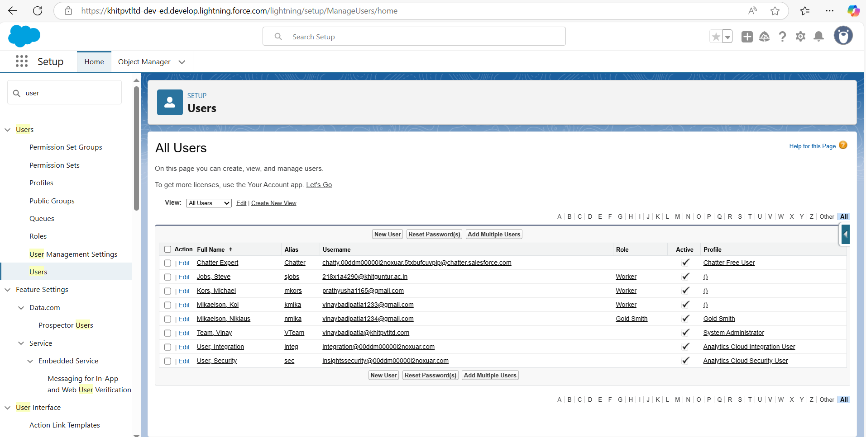

# Create User

##### Go to Setup Menu:

Log in to your Salesforce account.

Click on the gear icon in the upper right corner of the screen. Select Setup from the dropdown menu.

##### Navigate to Users:

lick on Users under User Management.

##### Create a New User:

Click on the New User button at the top of the Users page.

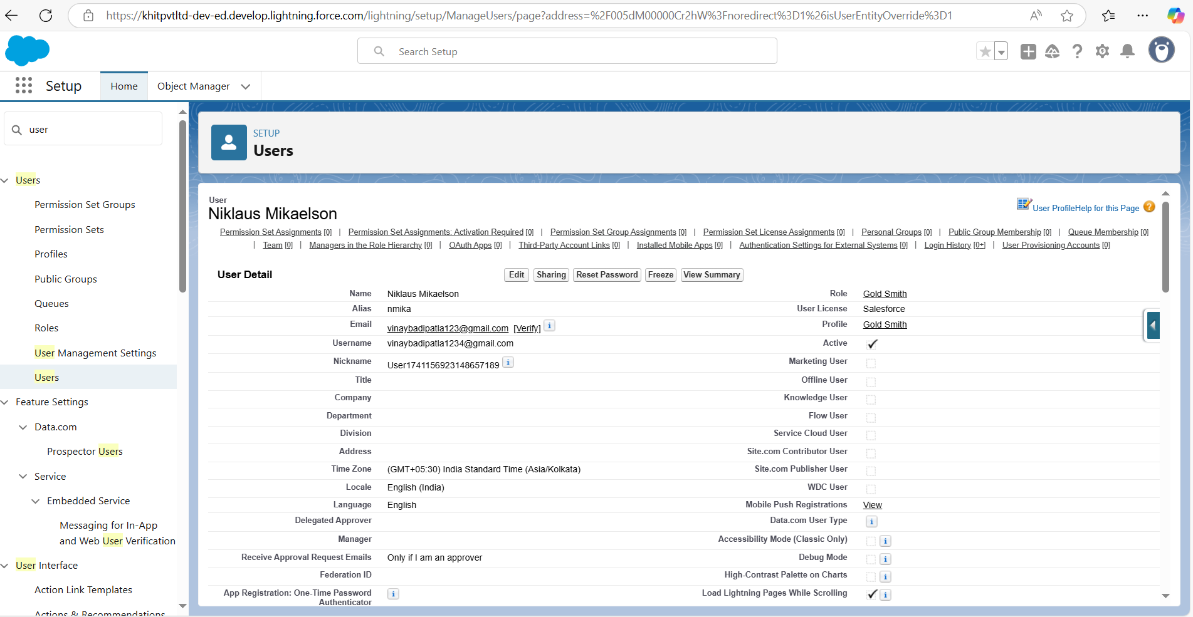

##### Fill in the Required Fields:

**First Name:** Enter the first name (e.g., Niklaus).

**Last Name:** Enter the last name (e.g., Mikaelson).

**Alias:** Enter an alias name (a short name or abbreviation).

**Email:** Enter your personal email address.

**Username:** Enter a username in the format of [vivek@khit.com](mailto:vivek@khit.com) (e.g., [niklaus.mikaelson@company.com).](mailto:niklaus.mikaelson@company.com)

**Nickname:** Enter a nickname.

**Role:** Select Gold Smith from the dropdown menu.

**User License:** Select Salesforce from the dropdown menu.

**Profile:** Select Gold Smith from the dropdown menu.

##### Save the New User:

After filling in all the required fields, click the Save button at the bottom of the page.

# User 2

##### Go to Setup Menu:

Log in to your Salesforce account.

Click on the gear icon in the upper right corner of the screen. Select Setup from the dropdown menu.

##### Navigate to Users:

In the Quick Find box on the left side of the Setup screen, type Users. Click on Users under User Management.

##### Create a New User:

Click on the New User button at the top of the Users page.

##### Fill in the Required Fields for the First User:

First Name: Kol

**Last Name:** Mikaelson

**Alias:** Enter an alias name (a short name or abbreviation).

**Email:** Enter your personal email address.

**Username:** Enter a username in the format of [vivek@khit.com](mailto:vivek@khit.com) (e.g., [kol.mikaelson@company.com).](mailto:kol.mikaelson@company.com)

**Nickname:** Provide a nickname.

**Role:** Select Worker from the dropdown menu.

**User License:** Select Salesforce Platform from the dropdown menu.

**Profile:** Select Worker from the dropdown menu.

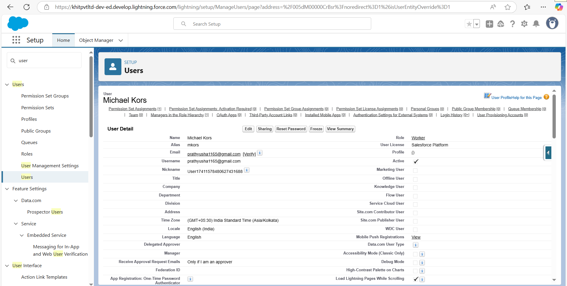

##### Save the New User:

After filling in all the required fields, click the Save button at the bottom of the page.

# MODULE-9. Page layouts

Page Layout in Salesforce allows us to customise the design and organise detail and edit pages of records in Salesforce. Page layouts can be used to control the appearance of fields, related lists, and custom links on standard and custom objects' detail and edit pages.

### To Create a Gold Page layout

##### Go to Setup Menu:

Log in to your Salesforce account.

Click on the gear icon in the upper right corner of the screen. Select Setup from the dropdown menu.

##### Navigate to Object Manager:

In the Quick Find box on the left side of the Setup screen, type Object Manager. Click on Object Manager.

##### Search for the Object (Item):

In the Object Manager, use the search bar to find the object named Item. From the dropdown menu next to the object, click on Edit.

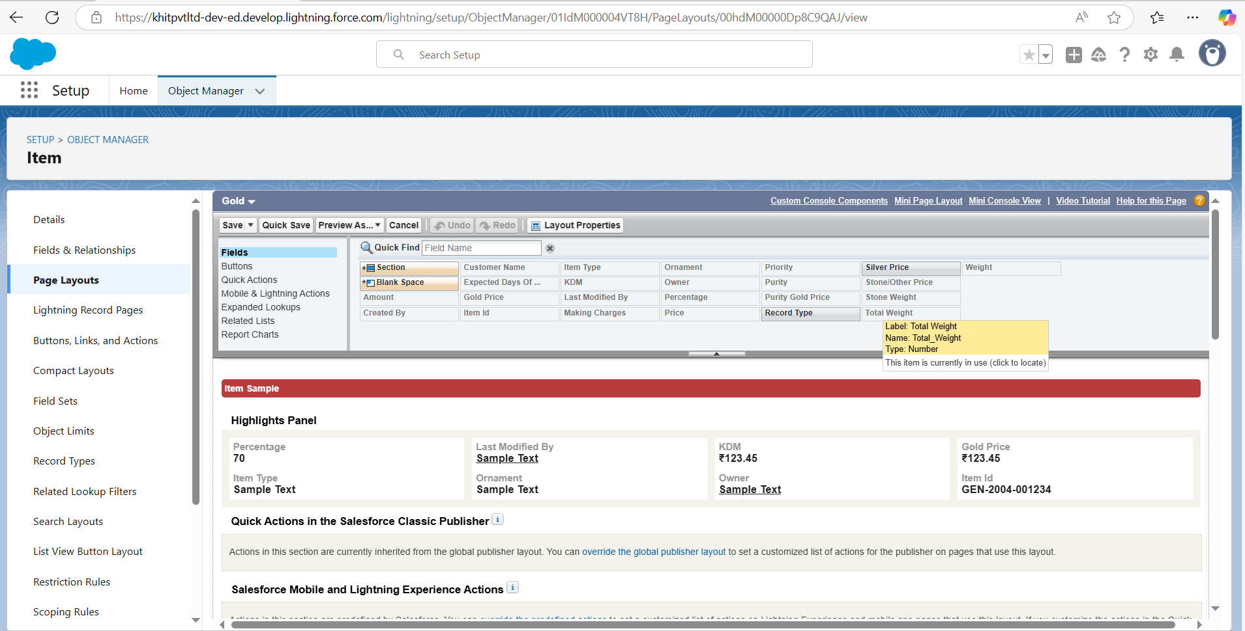

##### Create a New Page Layout:

Click on Page Layout in the left sidebar.

Click on the New button to create a new page layout.

##### Name the Page Layout:

In the Page Layout Name field, enter the name Page Layout for Gold. Click on the Save button.

##### Arrange the Fields:

In the Information Section, arrange the fields as shown in the example. Remove any fields that are related to Silver.

Click Ok to confirm the changes.

##### Save the Page Layout:

After arranging the fields and making the necessary changes, click the Save button.

### To Create a Sliver Page layout

##### Go to Setup Menu:

Log in to your Salesforce account.

Click on the gear icon in the upper right corner of the screen. Select Setup from the dropdown menu.

##### Navigate to Object Manager:

In the Quick Find box on the left side of the Setup screen, type Object Manager.

Click on Object Manager.

##### Search for the Object (Item):

In the Object Manager, use the search bar to find the object named Item. From the dropdown menu next to the object, click on Edit.

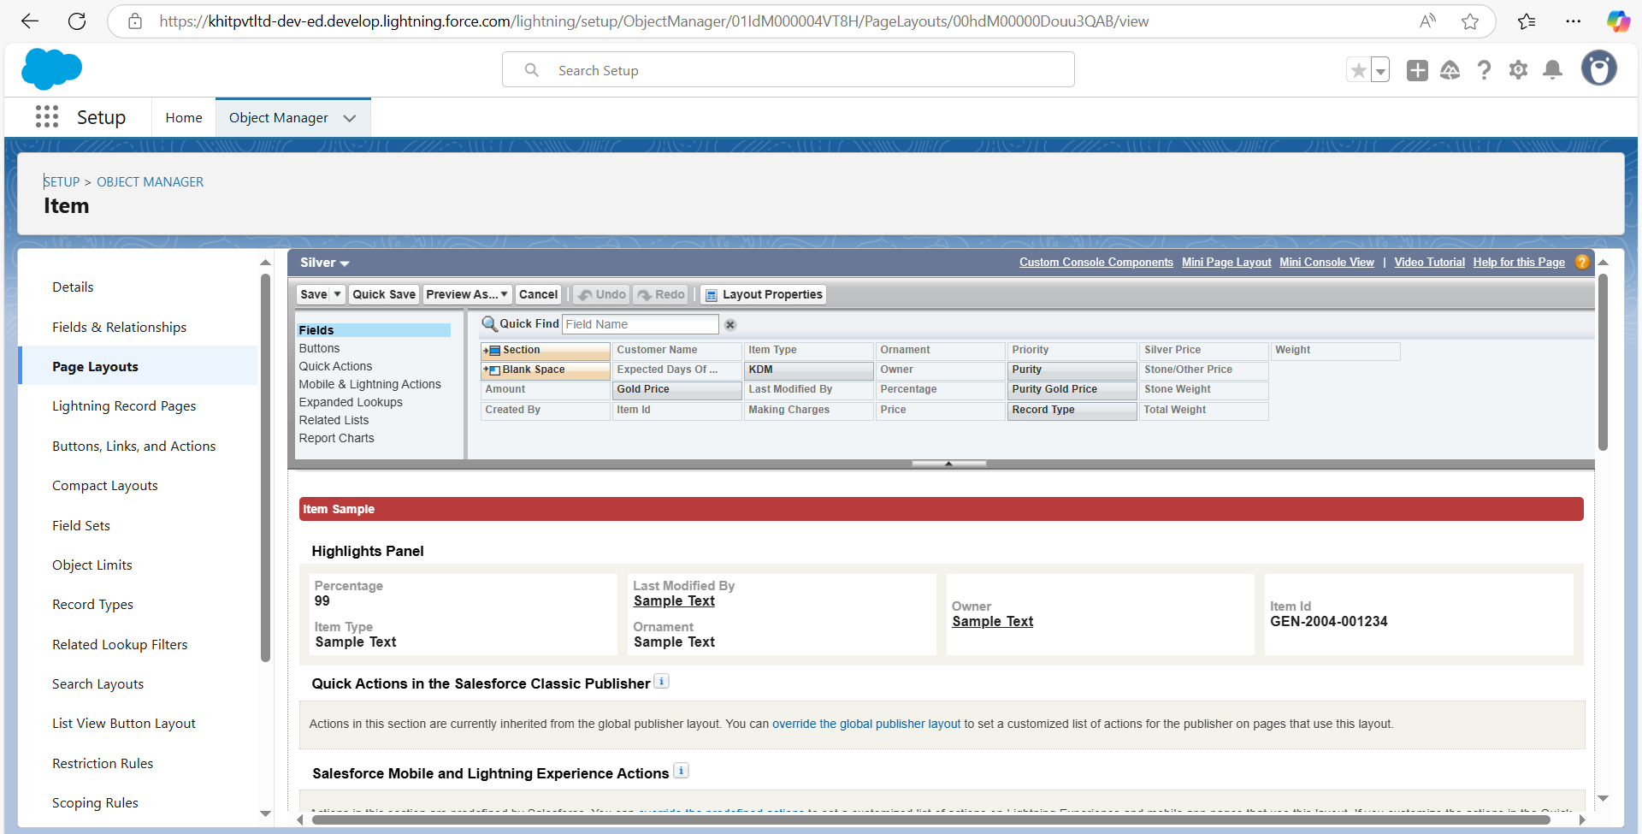

##### Create a New Page Layout:

Click on Page Layout in the left sidebar.

Click on the New button to create a new page layout.

##### Name the Page Layout:

In the Page Layout Name field, enter the name Page Layout for Silver. Click on the Save button.

##### Arrange the Fields:

In the Information Section, arrange the fields as shown in the example. Remove any fields that are related to Gold.

Click Ok to confirm the changes.

##### Save the Page Layout:

After arranging the fields and making the necessary changes, click the Save button.

# MODULE-10. Record Types

Record Types are a way of grouping many records of one type for that object. These can be applied to any standard or custom object, and allow you to have a different page layout, fields, required fields, and picklist values. Record types allow administrators to create a different page layout with custom picklist fields and values for the same business process and various business processes

##### Go to Setup Menu:

Log in to your Salesforce account.

Click on the gear icon in the upper right corner of the screen. Select Setup from the dropdown menu.

##### Navigate to Object Manager:

In the Quick Find box on the left side of the Setup screen, type Object Manager.

Click on Object Manager.

##### Search for the Object (Item):

Use the search bar in the Object Manager to find the object named Item. Click on the object from the search results.

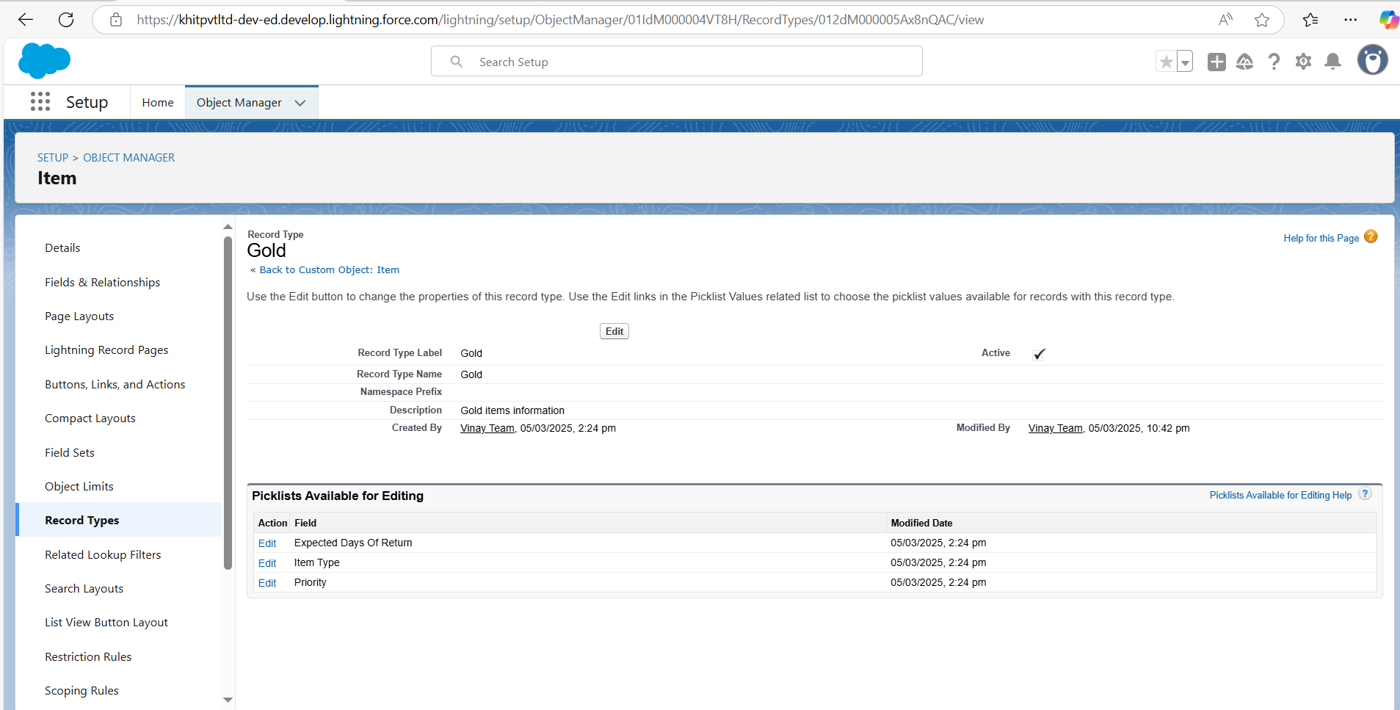

##### Edit the Object:

From the dropdown menu next to the object, click on Edit.

##### Create a New Record Type:

Click on Record Types in the left sidebar.

Click on the New button to create a new record type.

##### Fill in the Required Fields:

**Select Existing Record Type:** Choose Master.

**Record Type Label:** Enter Gold.

**Description:** Enter Gold items information.

##### Manage Profile Availability:

Uncheck the Make Available checkbox.

Scroll down and check the boxes for the profiles Gold Smith, Worker, and System Administrator.

Click on Next.

##### Apply Different Layout for Each Profile:

Select Apply a different layout for each profile.

Change the page layout to Page Layout for Gold for the profiles Gold Smith, Worker, and System Administrator.

Click on Save & New.

### Creating Another Record Type

Follow the same steps as above to create a new record type with the

**Record Type Label:** Silver

**Description:** Silver items information

**Page Layout:** Use Page Layout for Silver

### MODULE-11. Permission sets

A standard permission set consists of a group of common permissions for a particular feature associated with a permission set licence. Using a standard permission set saves you time and facilitates administration because you don't need to create the custom permission set.

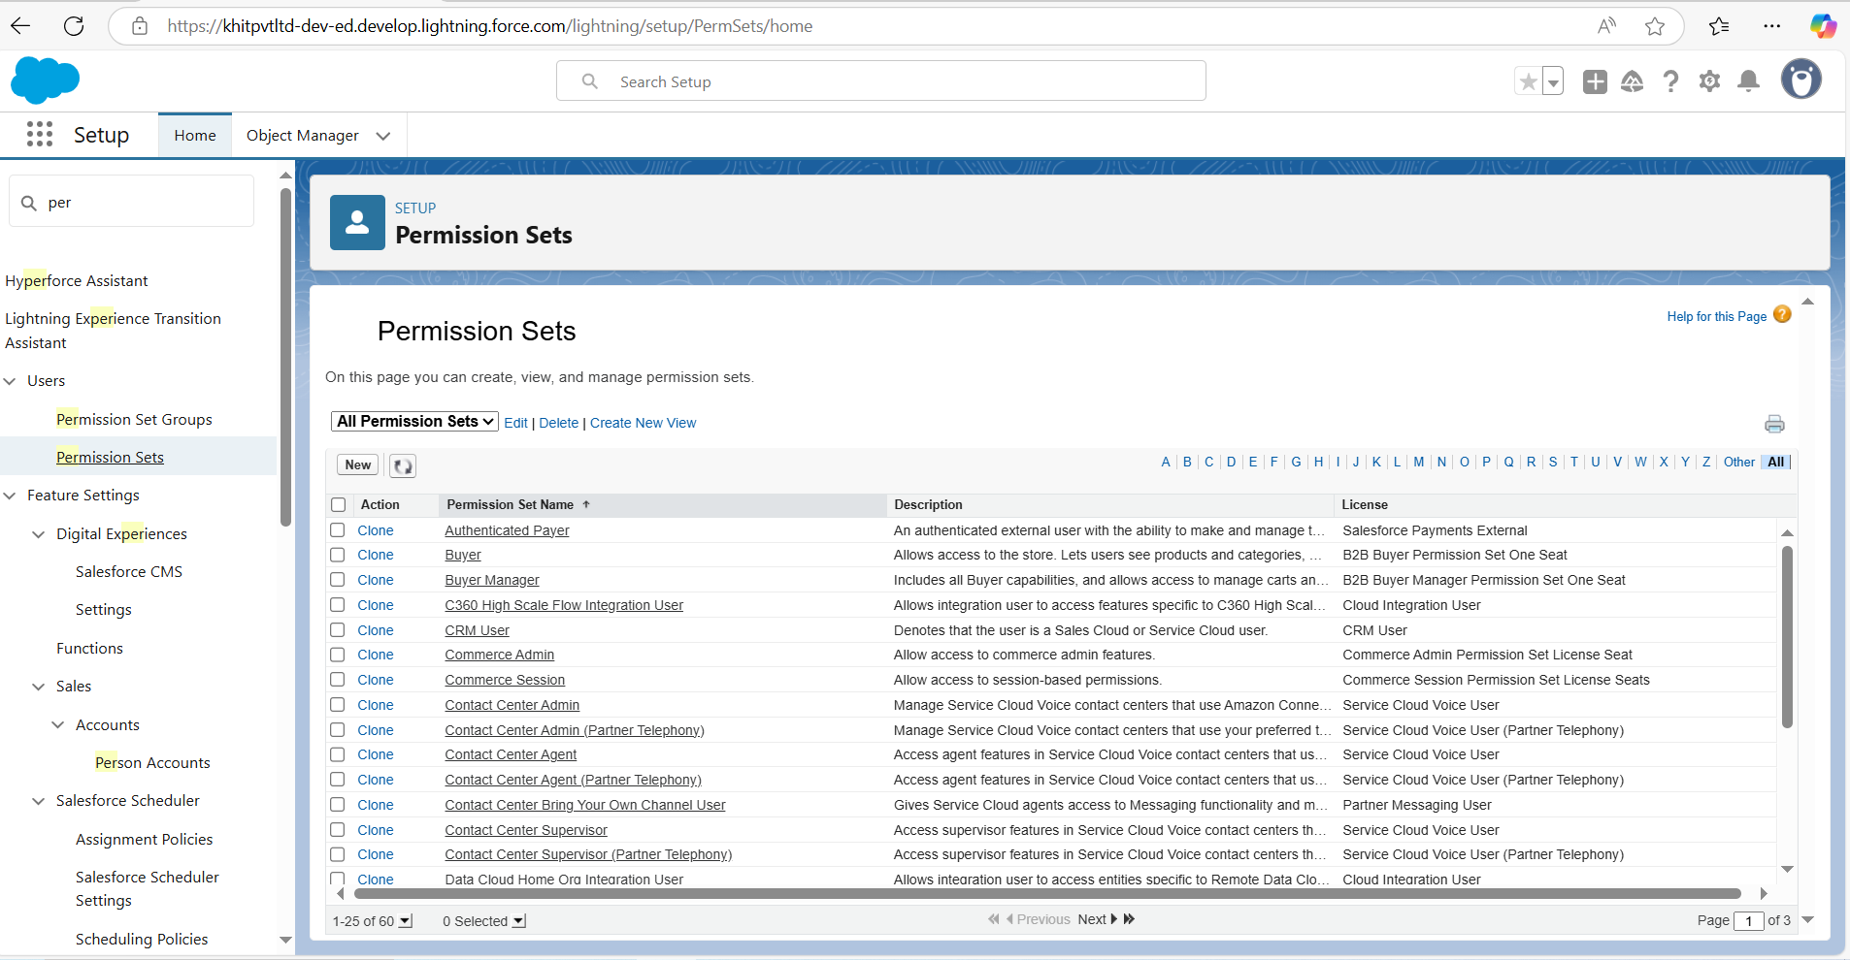

### Creating permission set

##### Go to Setup Menu:

Log in to your Salesforce account.

Click on the gear icon in the upper right corner of the screen.

Select Setup from the dropdown menu.

##### Navigate to Permission Sets:

In the Quick Find box on the left side of the Setup screen, type Permission Sets. Click on Permission Sets.

##### Create a New Permission Set:

Click on the New button to create a new permission set. Label**:** Enter the label name as Per to Worker.

The API Name will be auto-populated.

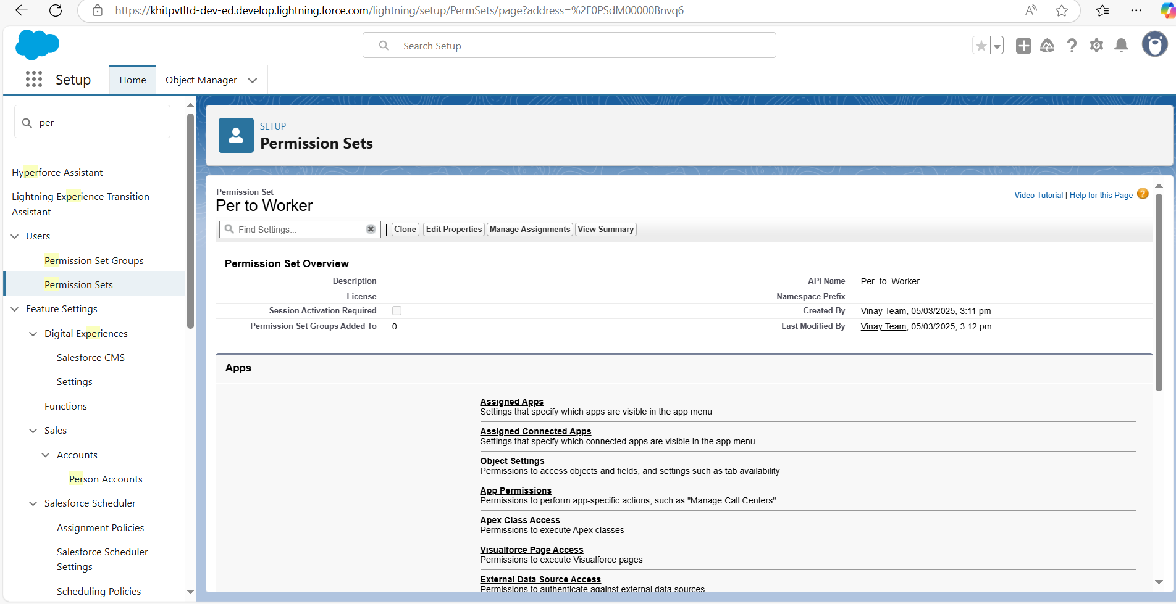

##### Configure Object Settings:

Under Apps, select Object Settings. Click on the Item object.

Click on Edit.

##### Set Record Type Assignments:

Under Item**:** Record Type Assignments, enable Gold and Silver.

In the Object Permissions, check the boxes for Read, Edit, and Create. Click on the Save button.

##### Manage Assignments:

After saving the permission set, click on Manage Assignments. Click on the Add Assignment button.

##### Assign Users:

Select the users which you have created in the user milestone, using the Worker profile.

Click on Next. Click on Assign. Click on Done.

### MODULE-12. Trigger

A trigger is a piece of Apex code that automatically runs before or after specific events, like record insertion, update, or deletion. Triggers are used to customise and automate actions in response to these events.

### Create a Trigger Handler class

##### Trigger handler:

A trigger handler is a design pattern that organises trigger logic into separate classes. This helps in keeping code organised, reusable, and easier to maintain. The trigger handler class contains methods that handle the specific logic for different trigger events as it promotes modular coding practices and reduces the chances of code duplication.

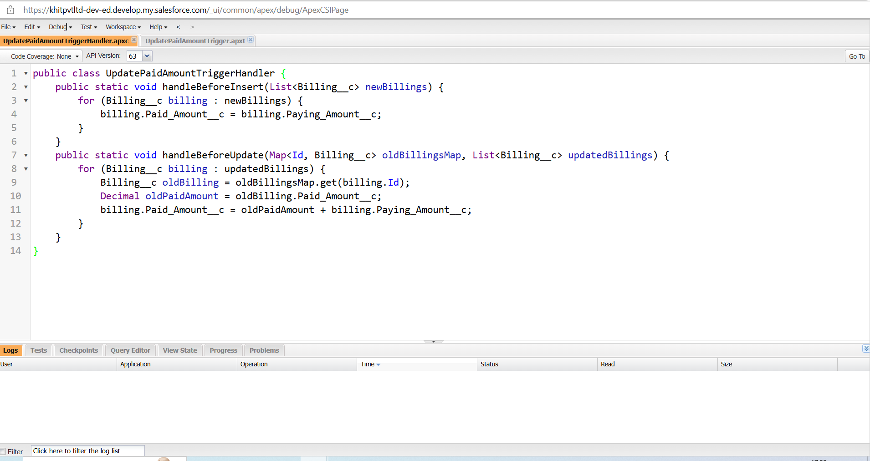

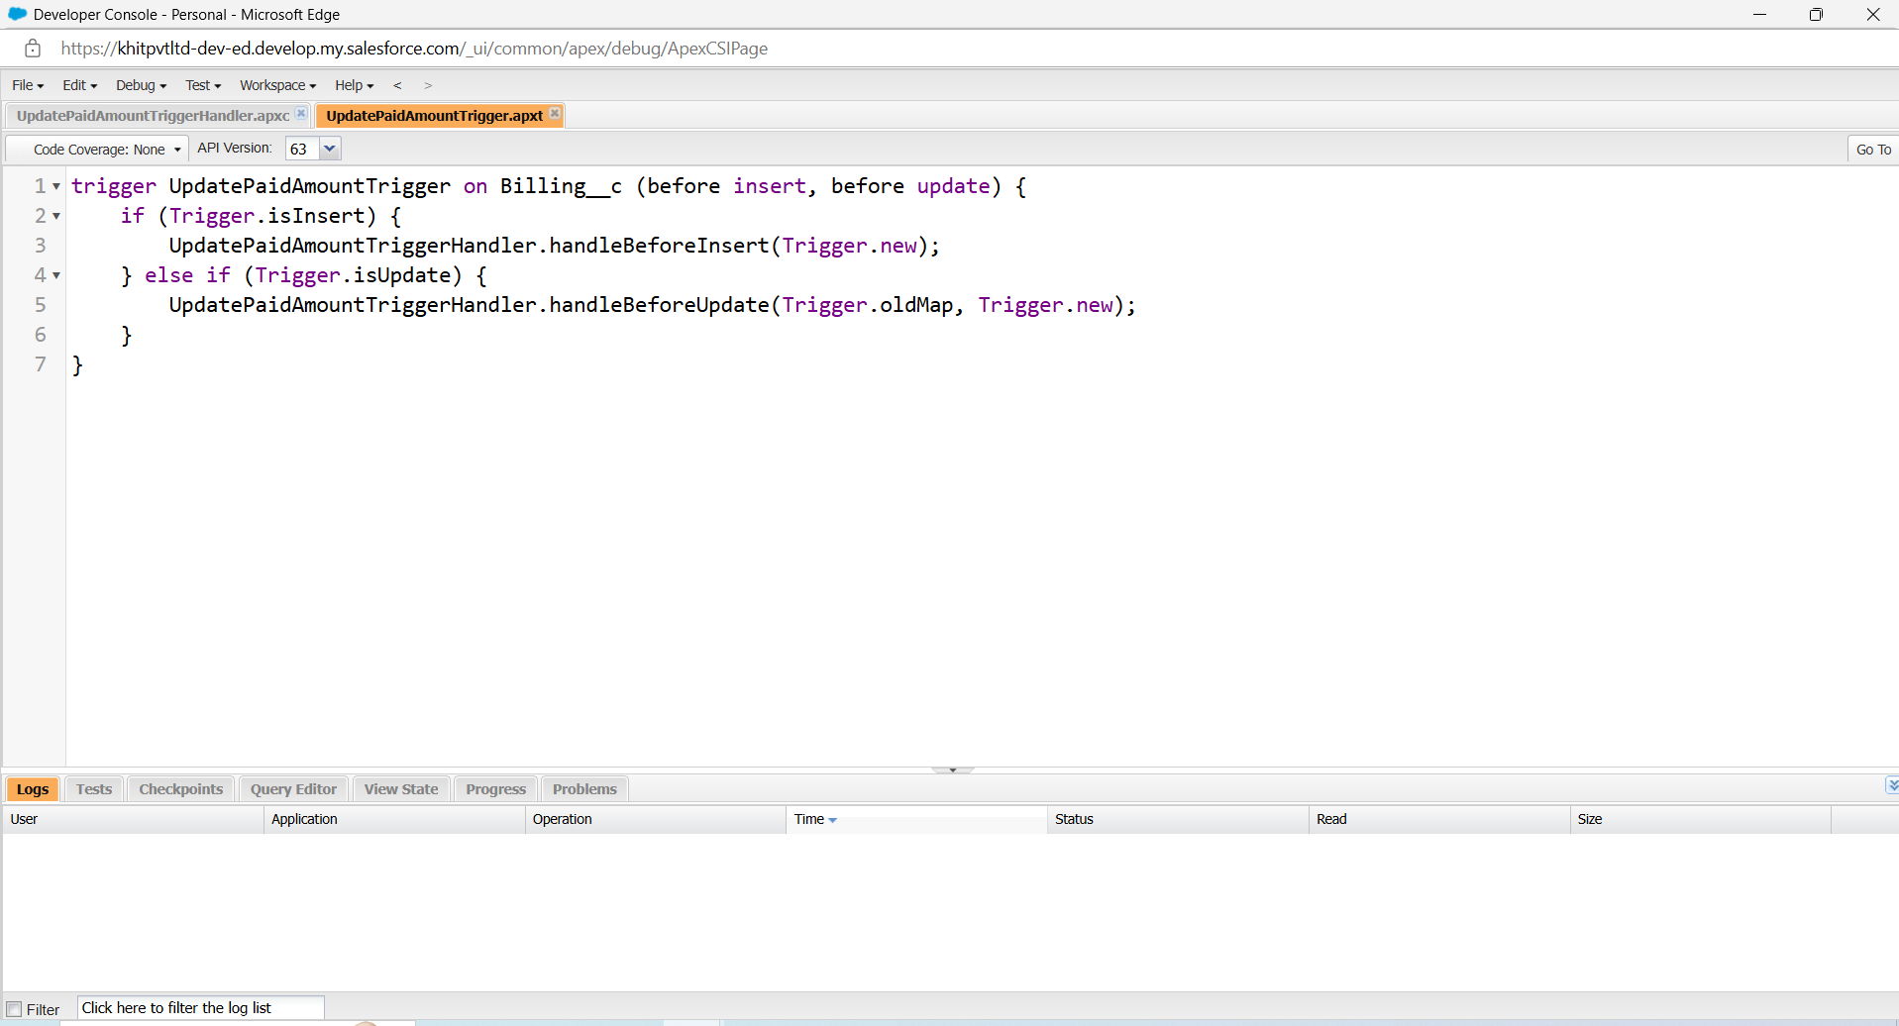

### MODULE-13. Permission sets

A standard permission set consists of a group of common permissions for a particular feature associated with a permission set licence. Using a standard permission set saves you time and facilitates administration because you don't need to create the custom permission set.

##### Creating permission set

1. **Go to Setup Menu:**

Log in to your Salesforce account.

Click on the gear icon in the upper right corner of the screen. Select Setup from the dropdown menu.

##### Navigate to Permission Sets:

In the Quick Find box on the left side of the Setup screen, type Permission Sets.

Click on Permission Sets.

##### Create a New Permission Set:

Click on the New button to create a new permission set. Label**:** Enter the label name as Per to Worker.

The API Name will be auto-populated.

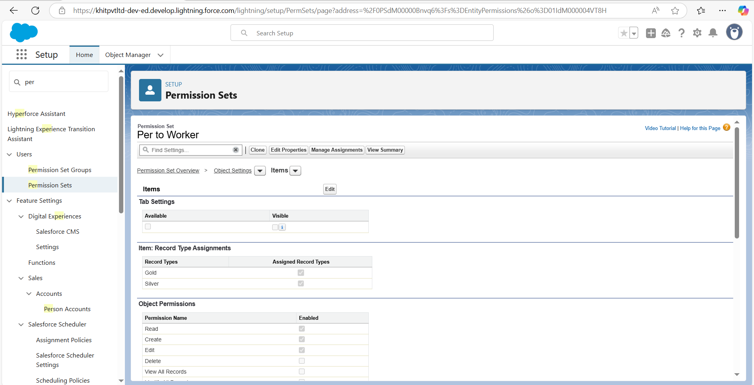

1. **Configure Object Settings:** Under Apps, select Object Settings. Click on the Item object.

Click on Edit.

##### Set Record Type Assignments:

Under Item**:** Record Type Assignments, enable Gold and Silver.

In the Object Permissions, check the boxes for Read, Edit, and Create. Click on the Save button.

##### Manage Assignments:

After saving the permission set, click on Manage Assignments. Click on the Add Assignment button.

##### Assign Users:

Select the users which you have created in the user milestone, using the Worker profile.

Click on Next. Click on Assign. Click on Done.

### MODULE-14. User Adoption

As a new Administrator, you perform user management tasks like creating and editing users, resetting passwords, granting permissions, configuring data access, and much more. In this unit, you will learn about users and how you add users to your Salesforce org.

##### Create a Record (Jewel Customer)

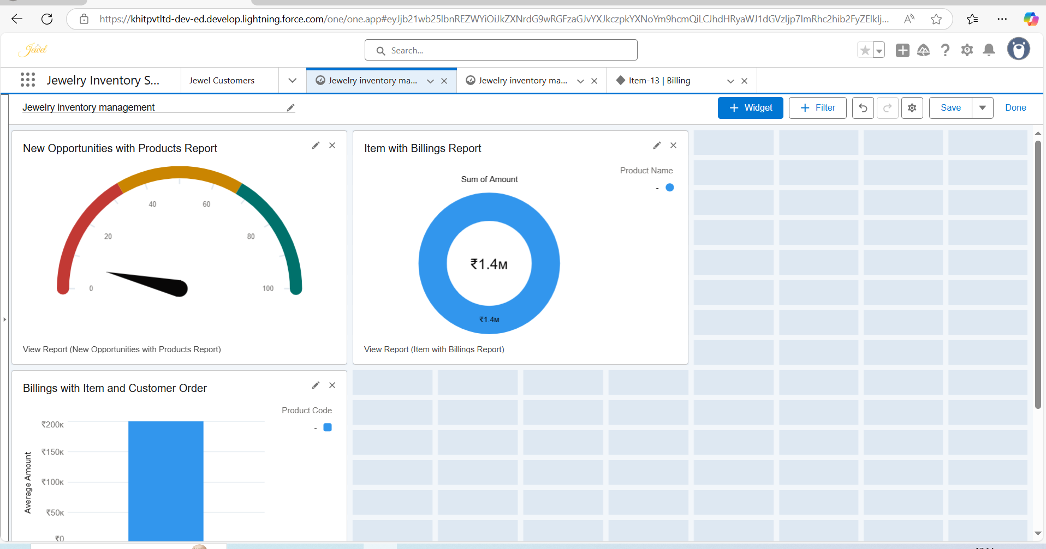

1. **Open App Launcher:**

Log in to your Salesforce account.

On the left side of the screen, click on the App Launcher icon.

##### Search for Jewellery Inventory System:

In the search bar within the App Launcher, type Jewellery Inventory System. Click on the Jewellery Inventory System from the search results.

##### Navigate to Jewel Customer Tab:

Click on the dropdown menu within the Jewellery Inventory System. Select the Jewel Customer tab from the dropdown menu.

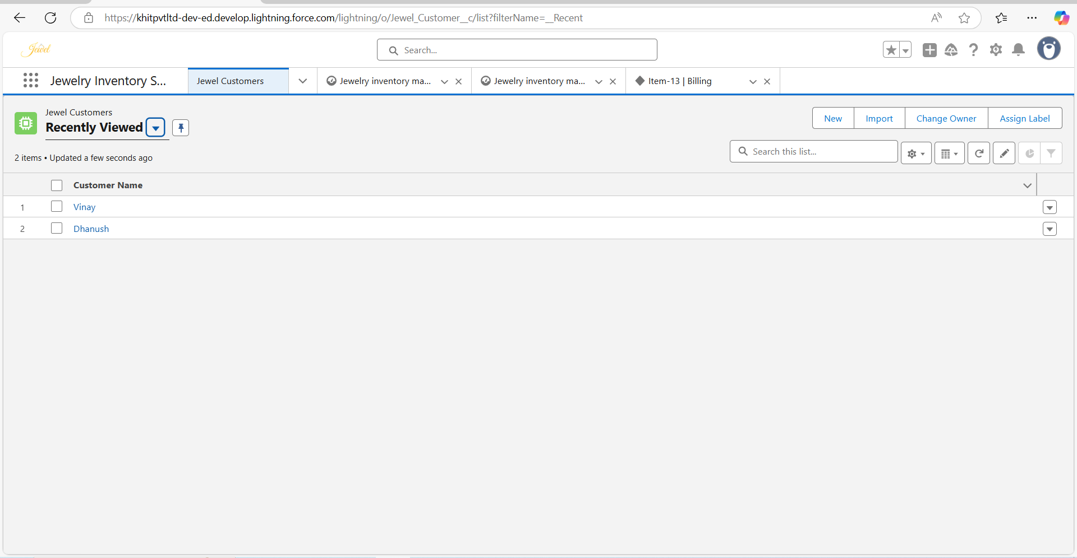

##### Fill in the Required Details:

Enter all the required details for the new Jewel Customer. Ensure that all mandatory fields are filled correctly.

##### Save the New Jewel Customer:

After filling in all the required details, click on the Save button to create the new Jewel Customer record.

##### Deleting a Jewel Customer Record in Salesforce Jewellery Inventory System

1. **Open App Launcher:**

Log in to your Salesforce account.

On the left side of the screen, click on the App Launcher icon.

##### Search for Jewellery Inventory System:

In the search bar within the App Launcher, type Jewellery Inventory System. Click on the Jewellery Inventory System from the search results.

##### Navigate to Jewel Customer Tab:

Click on the Jewel Customer tab within the Jewellery Inventory System.

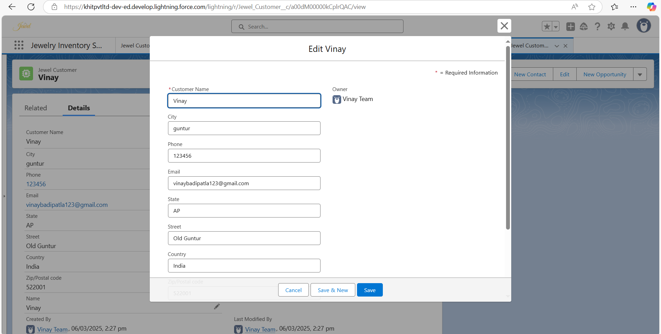

##### 3. Delete the Desired Jewel Customer Record:

Locate the record you want to delete.

Click on the arrow on the right-hand side of that particular record. Select Delete from the dropdown menu.

##### Creating Multiple Records

To create at least 10 records for each of the following objects: Jewel Customer, Price, Item, Customer Order, and Billing, follow the steps below:

##### Open App Launcher:

Log in to your Salesforce account. Click on the App Launcher icon.

##### Navigate to Each Object:

For each object (Jewel Customer, Price, Item, Customer Order, and Billing): Search for the object name in the App Launcher.

Click on the object from the search results.

##### Create New Records:

For each object, click on the New button. Click on the Save button.

### MODULE-15. Reports

Reports give you access to your Salesforce data. You can examine your Salesforce data in almost infinite combinations, display it in easy-to-understand formats, and share the resulting insights with others. Before building, reading, and sharing reports, review these reporting basics.

###### Types of Reports in Salesforce

* 1. Tabular
  2. Summary
  3. Matrix
  4. Joined Reports

**Create Report**

##### Go to the App:

Log in to your Salesforce account.

Navigate to the app where you want to create the report.

##### Navigate to Reports Tab:

Click on the Reports tab within the app.

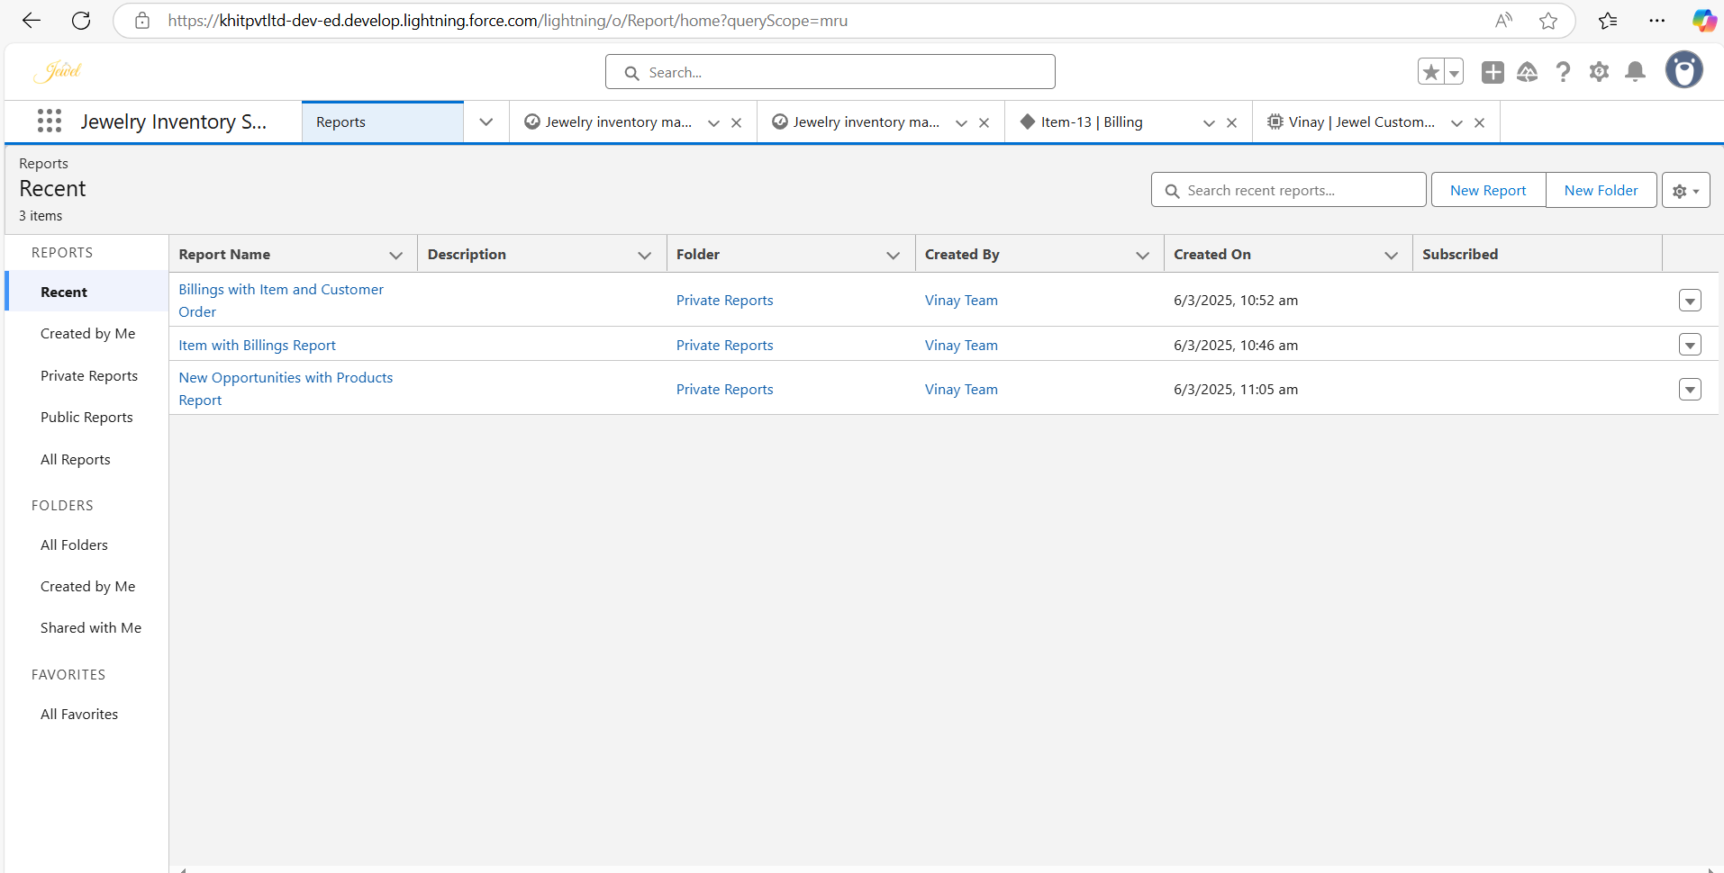

##### Create a New Report:

Click on the New Report button.

##### Select Report Type:

You can select the report type from the category list, the report type panel, or the search panel.

Click on Start Report to begin creating the report.

##### Customize Your Report:

Add fields from the left pane to your report as needed. Drag and drop fields into the report layout.

Customize the report by adding filters, groupings, and summaries.

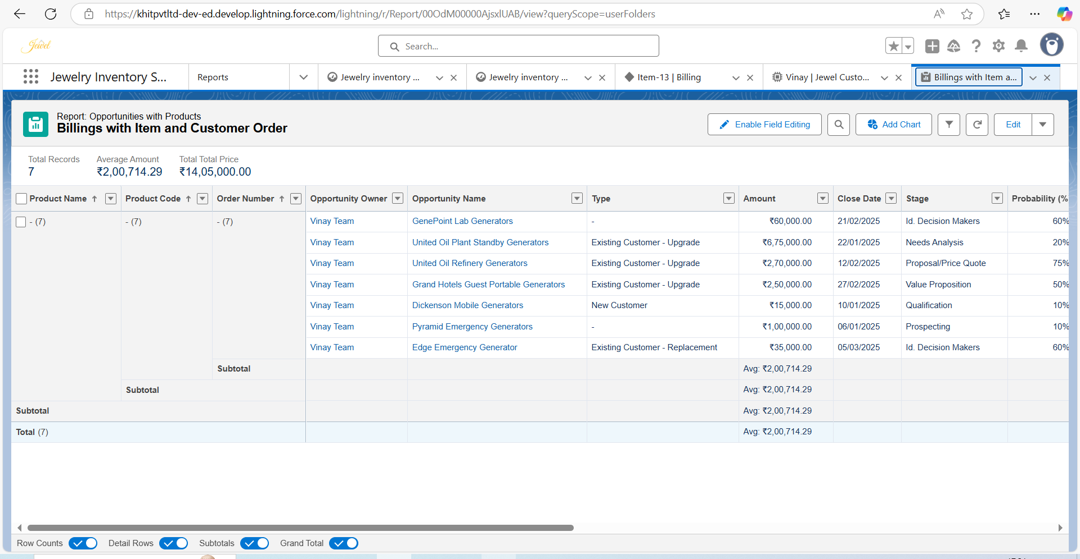

##### Save or Run the Report:

After customizing your report, you can either save it or run it. Click on the Save button to save your report.

Click on the Run button to generate the report and view the results.

### MODULE-16. Dashboards

Dashboards help you visually understand changing business conditions so you can make decisions based on the real-time data you’ve gathered with reports. Use dashboards to help users identify trends, sort out quantities, and measure the impact of their activities. Before building, reading, and sharing dashboards, review these dashboard basics.

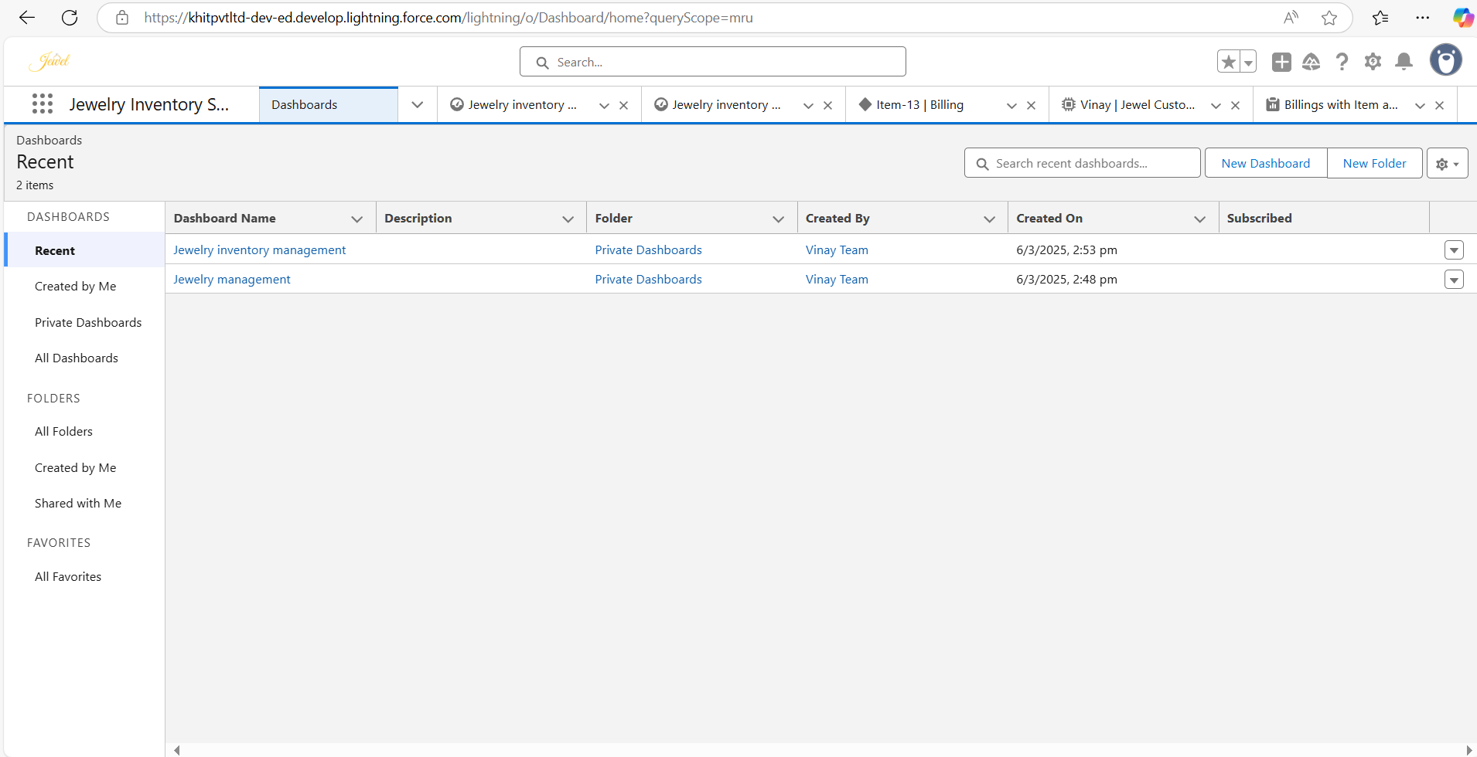

### Create Dashboard

##### Go to the App:

Log in to your Salesforce account.

Navigate to the app where you want to create the dashboard.

##### Navigate to Dashboards Tab:

Click on the Dashboards tab within the app.

1. **Create a New Dashboard:** Click on the New Dashboard button. Enter a name for the dashboard. Click on the Create button.

##### Add a Component:

Click on the Add Component button.

##### Select a Report:

Choose the report you want to use for the dashboard component. Click on Select.

##### Configure the Component:

Customize the component settings as needed.

Click on Add to add the component to the dashboard.

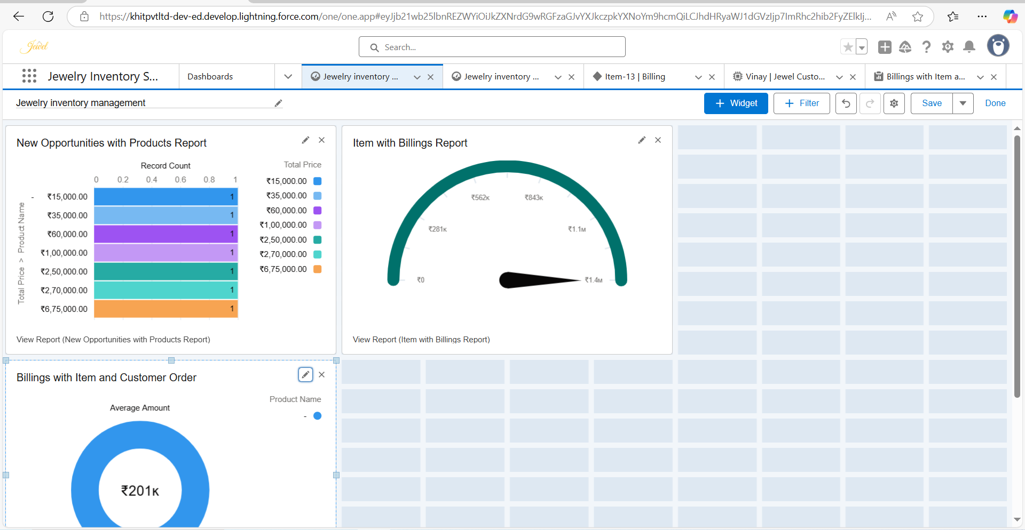

##### Save and Finish:

Click on the Save button to save the dashboard. Click on the Done button to complete the setup.

### MODULE-17. Flows

In Salesforce, a flow is a powerful tool that allows you to automate business processes, collect and update data, and guide users through a series of screens or steps.

Flows are built using a visual interface and can be created without any coding knowledge.

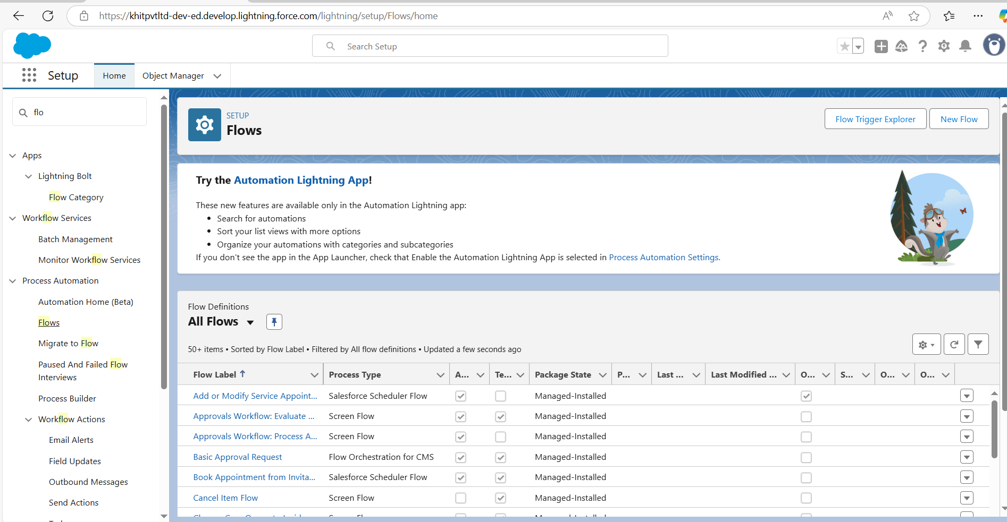

### Create a Flow

##### Go to Setup Menu:

Log in to your Salesforce account.

Click on the gear icon in the upper right corner of the screen. Select Setup from the dropdown menu.

##### Navigate to Flow:

In the Quick Find box on the left side of the Setup screen, type Flow. Click on Flows.

Click on the New Flow button.

##### Create a Record-triggered Flow:

Select Record-triggered Flow. Click on Create.

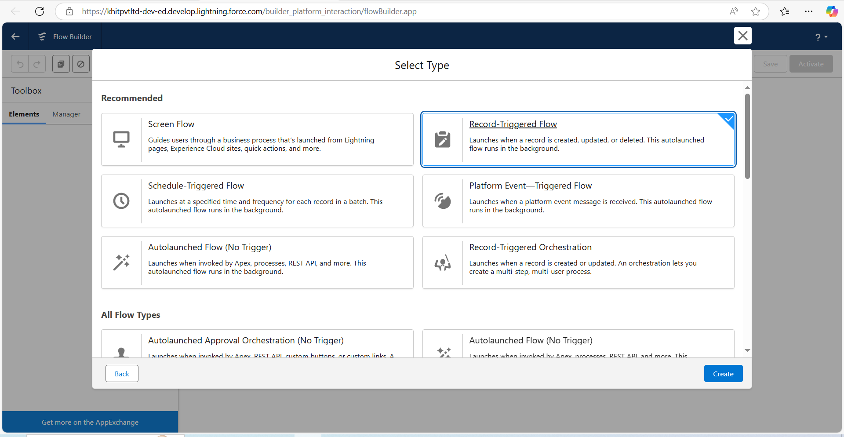

##### Select Object and Trigger:

Select the object Billing from the dropdown list. Select the trigger When a record is created or updated. Optimize the flow for Actions and Related Records.

Click on Done.

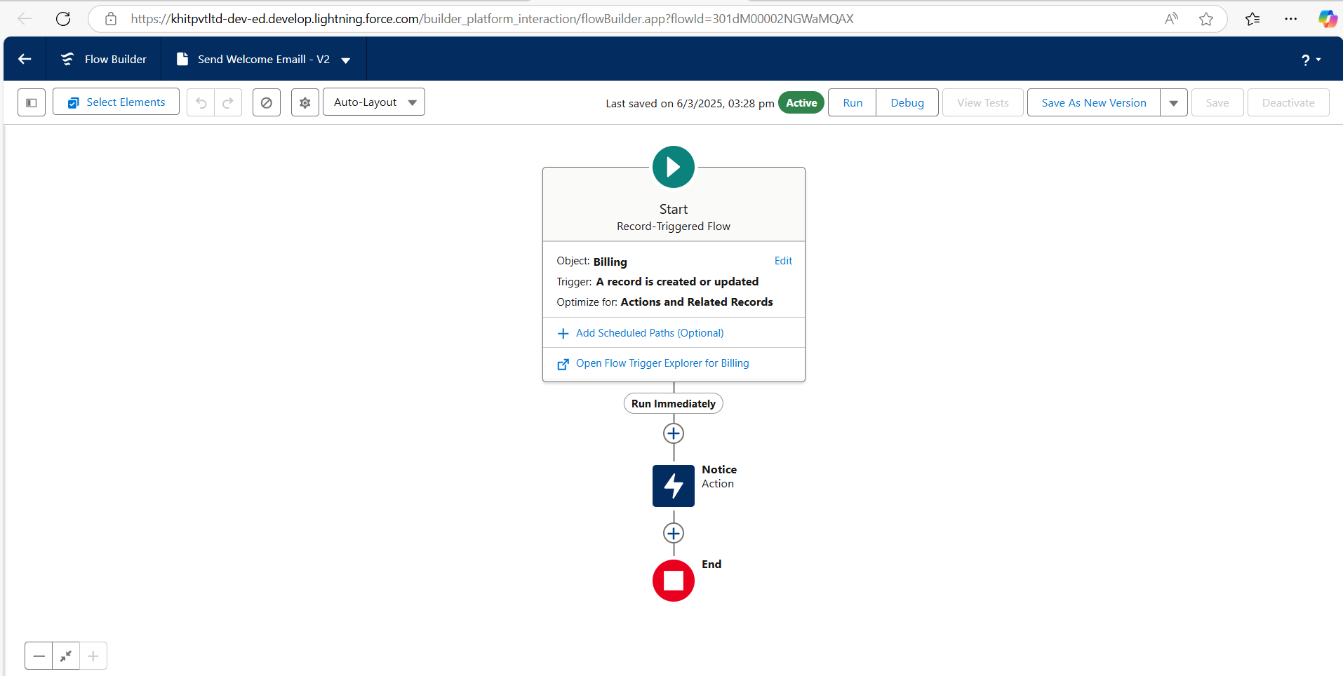

##### Switch to Free-form Mode:

Change the mode from Auto-layout to Free-form.

##### Create a New Resource:

In the toolbox, click on Manager. Click on New Resource.

Select the resource type as Text Template.

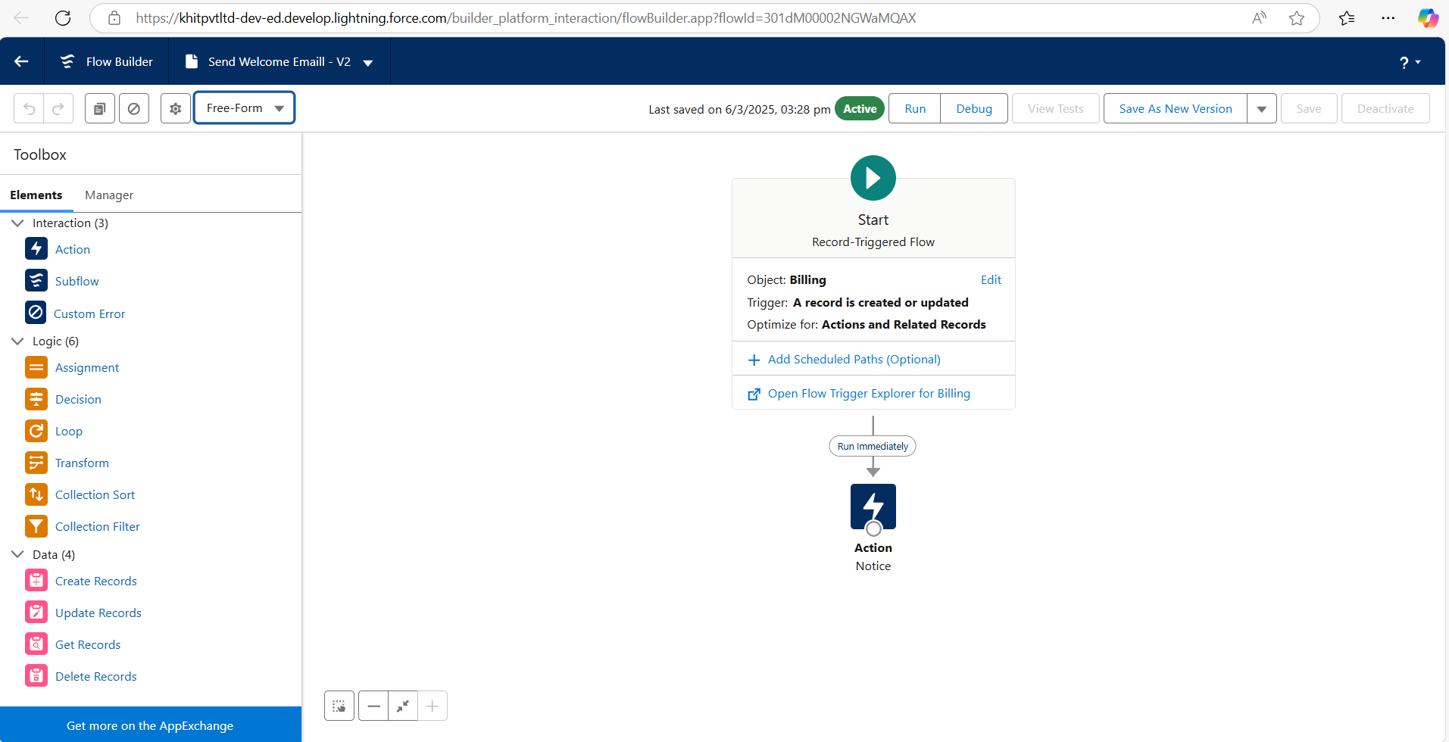

##### Configure Text Template:

Enter the API name as email body.

Change the view to Rich Text and then to Plain Text. In the body field, paste the following syntax:

Hello

Customer Name: {!$Record.Item r.Customer_Name r.Name}

Here are the details for the item you purchased with Jewellery Inventory System

Item Type: {!$Record.Item r.Item_Type c} Ornament: {!$Record.Ornament c}

Weight: {!$Record.Weight c} grams Amount: {!$Record.Amount c} Click on Done.

##### Add Action Element:

Click on Elements.

Drag the Action element into the preview pane.

In the action bar, search for Send Email and click on it.

##### Configure Action Element:

Give the label name as Notice.

The API name will be auto-populated.

Enable the body in Set Input Values for the Selected Action. Select the text template that was created.

##### Configure the Email Action:

Drag and drop the Action Element onto the Flow canvas.

Select the action type as "Send Email" or similar action based on your Salesforce version and configuration.

In the action configuration, specify the following:

Recipient Address:

Use the merge field {!$Record.Item_r.Customer_Namer.Email_c} to dynamically pull the customer’s email address.

Subject Line:

Enter the subject as **"**Welcome to Jewellery Inventory System**"**.

Body of Email (optional):

You can further customize the body of the email with any additional message or dynamic data.

##### Connect the Start to the Action Element:

Drag a path from the Start element to the Action Element in the Flow Builder.

##### Save and Activate the Flow:

After configuring all necessary elements, click Save.

Upon saving, Salesforce will automatically populate the Flow Label and Flow API Name.

Click Save to save the Flow.

Click Activate to activate the Flow.

##### Test the Flow:

Run a test to ensure that the customer receives the email with the correct subject and email address.

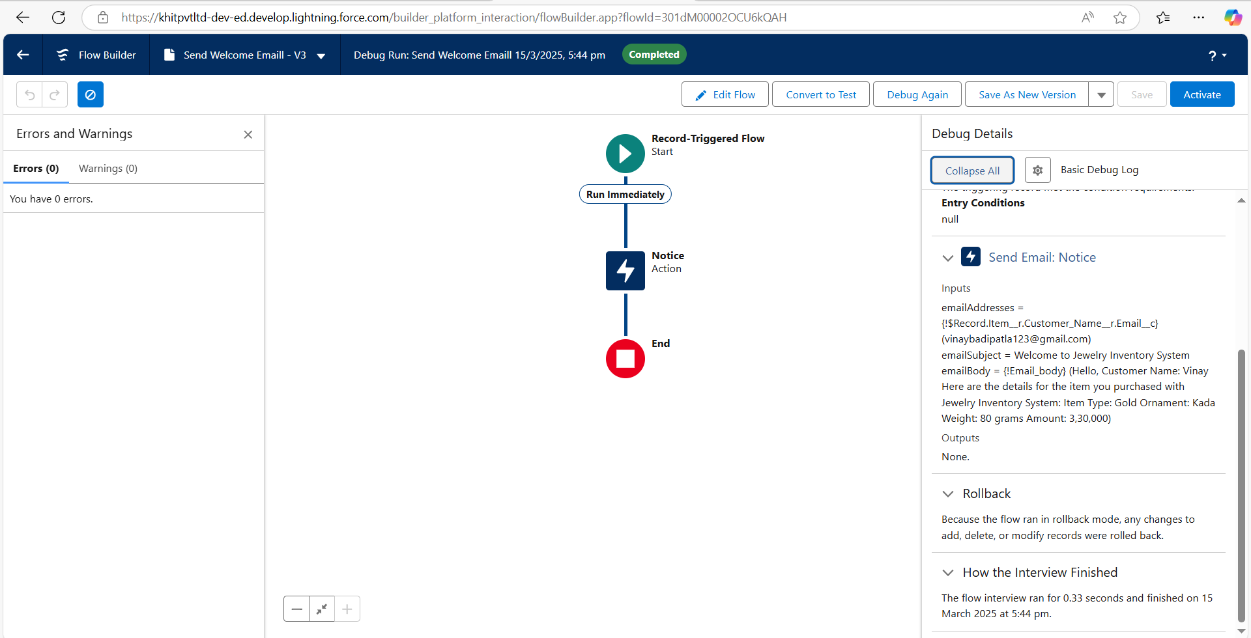

### Outcomes

The implementation of the CRM Application for Jewel Management has delivered significant benefits and improvements for jewelry businesses. The key outcomes of this project include:

##### Enhanced Customer Relationship Management

**Improved Customer Satisfaction:** The application enables personalized services and targeted marketing efforts, fostering customer loyalty and satisfaction.

**Comprehensive Customer Records:** Maintains accurate records of customer interactions, purchase history, and preferences, allowing for better customer engagement.

##### Optimized Inventory Management

**Real-Time Inventory Updates:** Provides real-time updates on inventory levels, preventing stockouts and overstocking, ensuring optimal stock levels.

**Efficient Stock Management:** Facilitates efficient tracking and control of inventory across multiple locations, reducing inventory carrying costs and losses.

##### Streamlined Sales Processes

**Automation of Sales Workflows:** Automates sales workflows, reducing manual efforts and increasing sales efficiency.

**Seamless Transactions:** Enables staff to process purchases, returns, and exchanges with ease, ensuring a smooth sales process.

##### Data-Driven Decision Making

**Insightful Reporting:** Generates detailed reports and dashboards that provide a clear visualization of key business metrics such as sales performance, inventory levels, and customer behavior.

**Informed Business Strategies:** Allows for informed decision-making based on accurate data, leading to better business strategies and growth opportunities.

##### Improved User Experience

**Intuitive Interface:** Offers a user-friendly interface, making it easy for staff to navigate and use the system effectively.

**Customizability:** Allows for customizable fields, tabs, and page layouts to meet the specific needs of the jewelry business.

##### Increased Operational Efficiency

**Reduction in Manual Processes:** Reduces manual processes and paperwork, leading to increased productivity and efficiency.

**Optimized Business Operations:** Streamlines and optimizes business operations, resulting in cost savings and improved profitability.

##### Scalability and Flexibility

**Scalable Solution:** Provides a scalable solution that can grow with the business, accommodating increasing inventory and customer base.

**Flexible Customization:** Offers flexibility and customization, allowing for future enhancements and integrations with other systems.

By leveraging the CRM Application for Jewel Management, jewelry businesses have experienced substantial improvements in their operations, customer relationships, and overall business performance. This Salesforce-based solution has proven to be a valuable asset, providing a competitive edge and setting the stage for sustained success in the market.

### Challenges and Solutions

##### Challenge 1: Complex Inventory Management

**Description:** Managing a diverse inventory of jewelry items with varying attributes (e.g., material, size, design) posed a significant challenge. Ensuring accurate tracking and control of inventory across multiple locations was critical.

**Solution:** Implemented a robust inventory management module that provides real-time updates on stock levels and facilitates efficient tracking of items. Customizable attributes were added to categorize and manage different types of jewelry accurately.

##### Challenge 2: Integration with Legacy Systems

**Description:** Integrating the new CRM application with existing legacy systems used by jewelry businesses was a complex task. Ensuring seamless data migration and interoperability was essential to avoid disruptions.

**Solution:** Developed custom integration tools and APIs to facilitate smooth data migration and communication between the CRM application and legacy systems. Thorough testing was conducted to ensure data integrity and seamless integration.

##### Challenge 3: User Adoption and Training

**Description:** Ensuring that staff members adopted the new CRM application and effectively used its features was a critical challenge. Resistance to change and lack of familiarity with new technology needed to be addressed.

**Solution:** Conducted comprehensive training sessions and workshops to educate staff on using the CRM application. Created user-friendly documentation and guides to assist users in navigating the system. Provided ongoing support to address any issues or questions.

##### Challenge 4: Scalability and Performance

**Description:** Designing a scalable solution that could handle the growing inventory and customer base of jewelry businesses was essential. Ensuring the application's performance under high load conditions was also a challenge.

**Solution:** Architected the application with scalability in mind, utilizing Salesforce's robust infrastructure and cloud capabilities. Implemented performance optimization techniques to ensure the application could handle high volumes of data and users efficiently.

##### Challenge 5: Customization and Flexibility

**Description:** Jewelry businesses have unique requirements and processes, necessitating a high degree of customization and flexibility in the CRM application. Addressing these diverse needs without compromising the system's integrity was challenging.

**Solution:** Developed a flexible and customizable application framework that allows businesses to tailor fields, tabs, and page layouts to their specific needs. Provided a range of configuration options to accommodate different business processes and workflows.

##### Challenge 6: Security and Compliance

**Description:** Ensuring the security of sensitive customer and inventory data was paramount. Compliance with industry regulations and data protection standards was also necessary.

**Solution:** Implemented robust security measures, including encryption, access controls, and regular security audits. Ensured compliance with relevant industry regulations and data protection standards to safeguard sensitive information.

### Future Recommendations

To ensure the continued success and evolution of the CRM Application for Jewel Management, the following recommendations are suggested for future development and enhancement:

##### Enhanced Mobile Accessibility

**Mobile App Development:** Develop a mobile version of the CRM application to provide staff with on-the-go access to key features and functionalities. This will enhance flexibility and productivity, especially for sales representatives and managers.

**Responsive Design:** Ensure that the CRM application is fully optimized for mobile devices, providing a seamless user experience across different screen sizes and platforms.

##### Integration with E-commerce Platforms

**E-commerce Integration:** Integrate the CRM application with popular e- commerce platforms to streamline online sales processes and synchronize inventory levels. This will enable jewelry businesses to manage both online and offline sales more efficiently.

**Omnichannel Support:** Provide support for omnichannel retail strategies, allowing customers to have a consistent shopping experience across various channels, including online stores, physical stores, and social media.

##### Enhanced Security and Data Protection

**Advanced Security Measures:** Continuously update and enhance security measures to protect sensitive customer and business data. Implement advanced encryption, multi-factor authentication, and regular security audits.

**Compliance with Regulations:** Ensure compliance with evolving data protection regulations and industry standards to maintain trust and credibility with customers.

##### Customer Self-Service Portal

**Self-Service Portal:** Develop a customer self-service portal that allows customers to access their purchase history, track orders, and manage their preferences. This will enhance customer satisfaction and reduce the workload on customer support teams.

**Chatbot Integration:** Integrate AI-powered chatbots to provide instant support and assistance to customers, addressing their queries and concerns in real-time.

##### Continuous User Training and Support

**Ongoing Training Programs:** Implement continuous training programs to keep staff updated on new features and best practices for using the CRM application. This will ensure effective utilization and maximize the benefits of the system.

**Dedicated Support Team:** Establish a dedicated support team to provide ongoing assistance and address any issues or questions that arise. Regular feedback sessions can help identify areas for improvement.

##### Customization and Flexibility

**Customizable Modules:** Offer customizable modules and features that allow businesses to tailor the CRM application to their specific needs and workflows. This will ensure the system remains relevant and adaptable to changing business requirements.

**Third-Party Integrations:** Provide seamless integration with third-party applications and tools, enabling businesses to extend the functionality of the CRM application and create a unified ecosystem.

By implementing these future recommendations, the CRM Application for Jewel Management can continue to evolve and meet the dynamic needs of jewelry businesses, ensuring sustained success and a competitive edge in the market.

### Conclusion

The CRM Application for Jewel Management represents a significant advancement in the way jewelry businesses manage their operations, customer relationships, and inventory. By leveraging the powerful capabilities of Salesforce, this comprehensive solution addresses the unique challenges faced by the jewelry industry and provides a platform for sustained success.

The application offers a range of features that enhance customer satisfaction, optimize inventory management, streamline sales processes, and enable data- driven decision-making. With its intuitive and user-friendly interface, jewelry businesses can effortlessly navigate and utilize the system, resulting in increased productivity and efficiency.

Throughout the development process, careful consideration was given to the specific needs of jewelry businesses, ensuring that the application is both customizable and scalable. This flexibility allows businesses to tailor the system to their unique requirements and accommodate future growth and changes.

The successful implementation of the CRM Application for Jewel Management has yielded numerous benefits, including improved customer relationships, efficient inventory management, and enhanced operational efficiency. By continuously evolving and integrating advanced technologies, the application will remain a valuable asset for jewelry businesses, providing a competitive edge in the market.

As the jewelry industry continues to evolve, this CRM application will serve as a cornerstone for innovation and excellence, empowering businesses to achieve their goals and thrive in an ever-changing landscape. With its robust features, seamless integration, and future-ready design, the CRM Application for Jewel Management sets the stage for a new era of success and growth in the jewelry business.

**THANK YOU**